1

The McEnerhinys of
Ballysallagh in the Sixteenth Century¹

LUKE McINERNEY

This paper extends on the author’s 2008 article in the Other Clare journal
which referenced a sixteenth century feud between branches of the
McEnerhiny (McInerney) lineage of Ballysallagh in Kilnasoolagh parish,
County Clare. This paper details the context behind the intra-sept feud
amongst the McEnerhiny deirbhfhine in light of a discovered Court of
Chancery bill. The paper will explore conflict among the extended kinfolk
of Irish septs and present evidence on landholding arrangements in the
sixteenth century Mac Conmara lordship of West Clann Chuiléin.

The McEnerhiny sept of Kilnasoolagh parish in the ancient territorial division of
Tradraighe in Thomond were an important landholding lineage in the sixteenth century.
As a second-order sept in the Mac Conmara lordship of West Clann Chuiléin the lineage
- known in Irish as Clann an Oirchinnigh² - held extensive lands in that parish and the
adjacent parishes of Quin, Kilmaleery and Clonloghan. The principal abode of the sept,
however, centered on Ballysallagh in Kilnasoolagh parish and their patrimonial lands
situated there since at least c.1400. Evidence to this end is found amongst references
to clerics of the ‘noble’ or landholding branch of the McEnerhinys in ecclesiastical
documents.
In the sixteenth century the McEnerhinys were recorded in official documents of the
New-English administration. Employing official sources—including the fortuitous
survival of a Court of Chancery bill and inquisition material—we can construct a
convincing picture of the McEnerhiny lineage at Ballysallagh. The recording of a land
dispute between two branches of the sept for the period 1565-1632 is of particular
interest as it spans the turbulent period when customary Irish law was replaced by
English common law and when landholding arrangements and social organization
changed markedly. It is thereby possible to provide a ‘micro-study’ of the McEnerhiny
sept in the sixteenth century and extrapolate information that can be used to understand
other sept-lineages of similar status.
The paper explores the possibility of utilizing surviving documentation to cast light
on an under-explored topic: landholding and conflict in the sixteenth century lordship of
West Clann Chuiléin. It is hoped that the micro-study attempted in this article can

¹ The author wishes to acknowledge the useful assistance in the preparation of this article by Brian Ó Dálaigh, Stuart Wrathmell and Martin Breen and assistance given regarding Petworth House manuscripts by Alison McCann at West Sussex Record Office, Chichester.
² Mac an Oirchinnigh (son of the erenagh). The surname is numerous in County Clare where the lineage were a sept of the
ruling Mac Conmara, with related branches in North Tipperary and Limerick. The name was recorded by Gaelic
ecclesiasts in fifteenth century Papal correspondence in its compact form ‘Macmeyrcheyn’ (Mac an Oirchinn) and in the
fuller form ‘Macanaerehynyg’. Early spellings give full expression to the internal guttural ‘ch’ phonetic and suggest a hard
syllabalistic ending. The former was retained in the nineteenth century spelling ‘McInerheny’ which prevailed in Irish
speaking districts in Clare. In this article I use the spelling ‘McEnerhiny’ as it approximates the general sixteenth century
spelling of McInerney. On spellings in the Papal Letters see Luke McInerney “Clerics and Clansmen: The Vicarages and
Rectories of Tradraighe in the Fifteenth Century”, North Munster Antiquarian Journal, Vol.48, 2008, pp.121.

2 LUKE McINERNEY

provide a template for similar research into sept lineages in other Gaelic lordships, as well as present an assessment of sept organisation at the local level.
Assessment of Sources
It is well known that research into sixteenth century Gaelic Ireland is fraught with
difficulty. The loss of official records on account of neglect, fire and deliberate targeting
of Gaelic manuscripts by English soldiers have all taken their toll.³ Careful application
of diverse sources can throw new light on sept-lineages in Gaelic lordships at a time of
transition and anglicisation. Much has been published on the ruling lineages of the Uí
Bhriain and Mac Conmara⁴ and recent research has also focused on the dynamics of the
clan system in Thomond, although this line of enquiry is still at its early stages.⁵ The
application of historical sources—Irish genealogies, administrative records and maps—
present an array of collective minutiae that can augment our understanding of sept-
lineages. Fortunately for the historian of sixteenth century Thomond an assortment of
historical sources survive and are accessible in public institutions. With prudent
assessment we can reconstruct the matrix of settlement and landholding that prevailed
amongst the lesser sept-lineages.
This paper relies chiefly on administrative sources which have limitations in their
accuracy and intent, but taken as a whole present a compelling window on McEnerhiny
freeholders at Ballysallagh. The State Papers of Ireland⁶ provide a backdrop to events
occurring locally, while the Irish Fiants⁷ provide a glimpse into ownership arrangements
of sept-lands and reads almost like a census distinguishing between gentlemen, yeomen,
husbandmen, labourers and kern and provides evidence on kinship bonds.⁸ Petworth
House Archives are the repository of rent ledgers and correspondence of the Earls of
Thomond—later Earls of Egremont—and hold valuable sixteenth and early seventeenth
century estate records including the 1619 inquisition into lands held by Donough
O’Brien, fourth Earl of Thomond, (PHA B.26.T.16) and the 4 January, 1624 inquisition
post mortem of Donough O’Brien (PHA Ms 1141).
The inquisition material transcribed by James Frost⁹ remains a touchstone for
research into Thomond. The recording, in abstract form, of 218 inquisitions post
mortem prior to their destruction in 1922, furnishes the historian with a powerful tool

³ Kenneth W. Nicholls, “Genealogy”, The Heritage of Ireland, Neil Buttimer, Colin Rynne, Helen Guerin (eds), The Collin Press, Cork, 2000, pp.156-160, p.157.
⁴ See, for example, N.C. McNamara, The Story of an Irish Sept: Their Character & Struggle to Maintain Their Lands in
Clare, 1896, republished by Martin Breen, Ruan, 1999 and John O’Donoghue, Historical Memoir of the O’Brien’s,
Hodges, Smith & Co., Dublin, 1860, republished by Martin Breen, Ruan, 2002. On more specific studies see Aoife Nic
Ghiollamhaith, “Kings and Vassals in Later Medieval Ireland: The Uí Bhriain and the MicConmara in the Fourteenth
Century”, Colony and Frontier in Medieval Ireland, Essays Presented to J. F. Lydon, eds., Terry Barry, Robin Frame &
Katherine Simms, Hambledon Press, London, 1995, pp.201-216; Andrew J. O’Regan, Thomond and the Tudor Crown:
Enforced Change in a Gaelic Lordship, unpublished PhD thesis, University College Dublin, 1987 and Brian Ó Dálaigh,
“From Gaelic Warlords to English Country Gentlemen: the O’Briens of Thomond 1543-1741, The Other Clare, Vol.25,
2001, pp.40-42.
⁵ Notable examples include Patrick Nugent, The Gaelic clans of Co. Clare and their territories 1100-1700 A.D, Geography
Publications, Dublin, 2007 and Patrick Nugent, “The Dynamics of the Clan System in Fourteenth Century Clare”, County
Clare Studies, Ciarán Ó Murchadha (ed), Clare Archaeological and Historical Society, Ennis, 2000, pp.55-71. Also see
the author’s article on the lordship of West Clann Chuiléin in Luke McInerney, “The West Clann Chuiléin Lordship in 1586: Evidence from a Forgotten Inquisition”, North Munster Antiquarian Journal, Vol. 48, 2008, pp.33-62.
⁶ Mary O’Dowd (ed), Calendar of State Papers, Ireland, Tudor Period 1571-1575, Kew Public Record Office, Irish Manuscript Commission, 2000.
⁷ The Irish Fiants of the Tudor Sovereigns: During the Reigns of Henry VIII, Edward VI, Phillip & Mary, and Elizabeth I, Éamonn de Búrca Publisher, Dublin, 1994.
⁸ Mary O’Dowd, Power, Politics and Land: Early Modern Sligo 1568-1688, Institute of Irish Studies, Belfast, 1991, p.86. 9 James Frost, A History and Topography of the County of Clare, 1893, (reprint), Dublin, 1973.

McENERHINYS OF BALLYSALLAGH 3

for historical analysis. The usefulness of this source comes caveated with the point that inconsistencies and editing by Frost limits the utility of the inquisition material. Despite this, the material does not loose its chief utility and can be regarded as credible.¹⁰ Less known is the transcribing, in full, of an inquisition of the Court of Exchequer held at Galway in 1586 by the antiquarian R.W. Twigge.¹¹ This inquisition has recently been the subject of analysis and remains the most important surviving document concerning the Mac Conmara lordship of West Clann Chuiléin.¹²
The published 1570 and 1574 ‘castle lists’¹³ are a unique source to the historian and provide commentary about the owners of tower-houses which can be corroborated against other long-standing sources for historical scholarship such as the 1585 Compossicion Booke of Conought,¹⁴ and the highly valuable compilation, the Inchiquin Manuscripts.¹⁵ The latter source is particularly useful in determining land transactions and pinpointing specific individuals.
This article focuses on a Court of Chancery bill that was salvaged from the 1922 fire
in the Public Records Office. This bill provides a detailed backdrop to the series of the
inquisitions into the landholding arrangements of McEnerhiny freeholders at
Ballysallagh. The Court of Chancery in Ireland was important in determining arbitrated
outcomes concerning land disputes and was a popular avenue for Gaelic freeholders
who sought redress under the law of equity. It was Dutch settler Matthew de Renzi who
noted the tenaciousness that the freeholders who pursued legal cases showed—not a
surprising point given the high stakes involved in alienating sept-land and the possibility
of violent conflict never too far from a litigant’s mind.¹⁶ Court of Chancery documents
expose detail concerning land transactions and hereditaments, making them a useful
primary source for delving into the world of litigation amongst freeholders, and the
application of English law in previously self-governing Gaelic lordships.
Research into Gaelic sept-lineages is greatly assisted by the publication of the Papal
Letters relating to Ireland,¹⁷ especially for the period 1396-1521. This valuable
compilation of ecclesiastical correspondence, along with the lesser known Regestum
Supplicationum¹⁸ which records petitions for Irish benefices, offer amassed information
concerning ecclesiastical administration in Gaelic dioceses. These sources underpin
evidence concerning the status and geographic locus of the McEnerhiny sept from
c.1400 and provide useful clues regarding the sept’s ecclesiastical connections. Later
ecclesiastical sources such as Bishop Worth’s Account Book of 1661¹⁹ are valuable in
determining tenurial arrangements on termon lands in Killaloe diocese in the early 1600s.

¹⁰ Patrick Nugent, “The interface between the Gaelic clan system of Co. Clare and the emerging centralising English
nation-state in the late sixteenth and early seventeenth century”, Irish Geography, Vol.40, No.1, 207, pp.79-98, p.82.
¹¹ R.W. Twigge, Materials for a History of Clann Cuilein, Add Ms 39260, Twigge Collection, British Library, pp.180-186.
¹² See Luke McInerney, “The West Clann Chuiléin Lordship in 1586: Evidence from a Forgotten Inquisition”
¹³ Martin Breen, “A 1570 List of Castles in County Clare”, North Munster Antiquarian Journal, Vol. XXXVI, 1995,
pp.130-138 and R.W. Twigge, “Edward White’s Description of Thomond in 1574”, North Munster Antiquarian Journal,
Vol. 1. No.2. 1910, pp.75-85.
¹⁴ A. Martin Freeman (ed), The Compossicion Booke of Conought, Irish Manuscripts Commission, Dublin, 1936.
¹⁵ John Ainsworth (ed), The Inchiquin Manuscripts, Irish Manuscripts Commission, Dublin, 1961.
¹⁶ Mary O’Dowd, “Gaelic Economy and Society” in Ciaran Brady & Raymond Gillespie, Natives and Newcomers: Essays
on the Making of Irish Colonial Society 1534:1641, Irish Academic Press, Dublin, 1986, pp.120-147, p.142.
¹⁷ J.A Twemlow, Calendar of Entries in the Papal Register Relating to Great Britain an Ireland, Vols. V-XIV, London;
Michael J. Haren Vols. XV, XVIII-XIX, Dublin, & Anne P. Fuller, Vols. XVI-XVII and XX, Dublin.
¹⁸ ASV Regestum Supplicationum, [microfilm record], National Library of Ireland.
¹⁹ Ms 1777, Typescript copy of a survey of lands in the diocese of Killaloe made for Bishop Worth, 1661, transcribed by (Rev) James B. Leslie, National Library of Ireland, 1936. The original manuscript can be accessed at the library of the Representative Church Body, Dublin [Ms D.14/1].

4 LUKE McINERNEY

Gaelic manuscripts are an under-utilized source for the local historian.²⁰ A careful
study of Gaelic material can aid research into sept origins. The arcane world of
genealogies, many copied from an original exemplar of medieval antiquity, are valuable
in so far as recording the landholding segment of a sept-lineage. In the words of one
historian the genealogies are akin to an “obsolete telephone directory from some small,
remote capital”.²¹ The accuracy of the Gaelic genealogies has been addressed
elsewhere²² however difficulties of language, script and other idiosyncrasies confer an
element of complexity on this source.
The principal Gaelic sources used in this paper include the saga-text Caithréim
Thoirdhealbhaigh²³ produced by a member of the hereditary learned Mac Craith family
in the mid-fourteenth century. While not recording contemporary events but rather
events prior to 1318 and written as a highly stylized propaganda piece for the ruling Uí
Bhriain kings, references to sept-lineages are likely to be accurate. The genealogical text
RIA Ms ²³.H.22 which sets out the division of the McEnerhiny into senior and junior
branches is reputed to have been transcribed in the nineteenth century from the roll
compiled by the professional poet-historian Maoilín Óg Mac Bruaideadha in c.1588.²⁴
This manuscript was also transcribed in the eighteenth century by Seán Ua Catháin and
the practice of presenting the McEnerhiny sept as two divided lineages is repeated,
presumably as this was set down in the original exemplar.²⁵
The recording of the two branches of the McEnerhiny sept is unique as it allows us
to date the compilation of the pedigree to the late sixteenth century while cross-
referencing with inquisition material the accuracy of the genealogy. In this manner, the
genealogical tract can be concluded to be credible and was probably compiled to
legitimise the seizure of the sept-lands by the ‘senior’ branch of the McEnerhiny sept.
The Mac Conmara genealogy known as RIA Ms 23 L.37 and containing material from
c.1380 was copied by a succession of scribes from the lost Leabhar Oiris compiled by the poetic-chronicler Uí Mhaoilchonaire family.²⁶ This genealogy is useful in identifying the historic origins of various Mac Conmara collateral sept-lineages, including the McEnerhiny. Similarly, the Book of Lecan²⁷ compiled in c.1418 by Gilla Ísu Mac Fir Bhisigha, a hereditary historian, pinpoints the Mac Conmara lineage and notes Donnchadh, the McEnerhiny progenitor.
The usage of bardic poetry can also provide evidence on the status of sept-lineages
in a Gaelic lordship, though the patronage of bardic poems were the domain of the lordly
families with the purpose of legitimising their suzerainty over subordinate vassal-septs.
In particular, the poem Créd fá seachnaim síol Aodha? compiled by Domhnall Ó Maoil-
chonaire for his patron Seán Mac Conmara, Lord of West Clann Chuiléin, (RIA Ms 784)
provides a different perspective on the role of kinship amongst the landholding sept-lineages.

²⁰ On Clare genealogies faithfully republished from manuscripts see Seán Ó hÓgáin, Conntae an Cláir: A Triocha Agus A
Tuatha, Oifig an tSolátair, Baile Átha Cliath, 1938.
²¹ K.V. Kelleher, “The Pre-Norman Irish Genealogies”, Irish Historical Studies, Vol.XVI, No.62, 1968-9, pp.138-141, p.138.
²² Kenneth Nicholls, “The Irish Genealogies: Their Value and Defects”, The Irish Genealogist, Vol.5, No.2, 1975, pp.256-
261 and T. Whitely Moran, “The Medieval Gaelic Genealogies III, The Irish Genealogist, Vol.5, No.1, 1974, pp.5-20.
²³ Sean Mac Ruaidhri Mac Craith, Caithréim Thoirdhealbhaigh: The Triumphs of Turlough, Standish Hayes O’Grady (ed),
Irish Texts Society, London, 1929, Vol I & II.
²⁴ R.W Twigge, Materials for a History of Clann Cuilein, Add Ms 39266, Twigge Collection, p.315 & p.317. Twigge
records that RIA Ms 23.H.22, p.11 was “transcribed in 1803 by Peter O’Conell from the Roll written by Maolin og Mac
Bruaideadha in the year A.D. 1588”.
²⁵ See RIA Ms 23 G. 4, pp.400-401. I thank Kenneth W. Nicholls for identifying the link between these genealogies. ²⁶ Kenneth Nicholls, “The Irish Genealogies: Their Value and Defects”, p.258.
²⁷ Kathleen Mulchrone (ed), The Book of Lecan: Leabhar Mór Mhic Fhir Bhisigh Leacain, The Irish Manuscripts
Commission, Dublin, 1937, p.434.
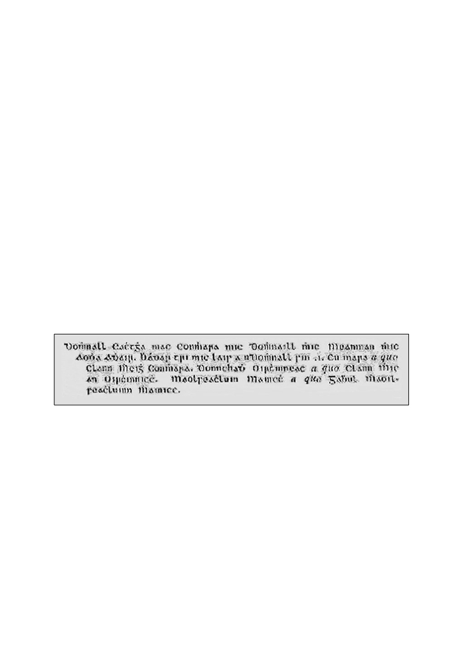

McENERHINYS OF BALLYSALLAGH 5

McEnerhinys of Ballysallagh: A micro-study
A micro-study of the McEnerhiny sept of sixteenth century Ballysallagh is useful in
determining the specifics of social organisation at the local level. Significant local
variation existed amongst sixteenth century Gaelic lordships,²⁸ and to this end a micro-
study can more accurately reflect specifics of the social order. With careful application
of sparse historical sources it is possible to reconstruct—albeit haphazardly and with a
degree of retrospectivity—the landholding arrangements and role of vassal-septs in the
Mac Conmara lordship. Greater engagement with historical sources can provide
comment on freeholders as a reading of the Inchiquin Manuscripts and Petworth House
Archive material reveals.
In the sixteenth century the McEnerhiny ranked amongst the most important
landholding sept-lineage in the Mac Conmara lordship of West Clann Chuilein. Despite
not being a professional learned family the McEnerhinys can be classified as a leading
vassal-sept of the Mac Conmara with a sept-estate second to the McClancy brehon clan
in terms of size.²⁹ Sources described the McEnerhiny as a ‘noble’ or aristocratic sept-
lineage, indicating their status as a landholding lineage with kinship ties to the ruling
Mac Conmara lineage.³⁰
According to the Gaelic genealogies the McEnerhinys (Mac an Oirchinnigh) were originally an erenagh sept, though it is uncertain which termon lands in east Clare they were attached to. The origins of the McEnerhinys have been discussed elsewhere³¹ however it is worth recounting their reputed progenitor, Donnchadh Mac Conmara, featured in RIA Ms 23 L.37 whose original exemplar dates from c.1380.³²
RIAMs 23 L.37 Genealogical tract: McEnerhiny descent from the Mac Conmara lineage³³

Domhnall Eachtgha Mac Conmhara mic Domhnall mhic Meanman mhic Aodha Adhair. Bhádar tri mic lais a nDomhnall sin .i. Cu mara a quo Clann Mheigh Conmhara. Donnchadh Oirchinneach a quo Clann Mhic an Oirchinnicch. Maolseachluin Mainech a quo Gabhul Mhaoilseachluinn Mhainicc.

²⁸ Bernadette Cuningham & Raymond Gillespie, Stories from Gaelic Ireland: Microhistories from the sixteenth-century
Irish annals, Four Courts Press, Dublin, 2003, p.13.
²⁹ Luke McInerney, “The West Clann Chuiléin Lordship in 1586: Evidence from a Forgotten Inquisition”, p.43.
³⁰ On descriptions of the McEnerhinys as a noble sept-lineage see Nollaig Ó Muraíle (ed) The Great Book of Irish
Genealogies, Dubhaltach Mac Fhirbhisigh, Vol. III, De Búrca Publishing, Dublin, 2003, p.693. This traditional account
cites Clann an Oirchinnigh (McEnerhinys) as among the nobles who descended from Caisín. Also see Anthony
Bruodin’s Propugnaculum Catholicae Veritatis Libris x Constructum, in Duasque Partes Divisum. Pars Prima Historica in Quinque Libros, Prague, 1669 where he refers to the lineage of Br Jeremias de Nerihiny (Jeremy McEnerhiny) who was killed by Cromwellian soldiers at Quin Friary in 1651 as “Tradrie in Tuomonia antiquae nobilitatis, magnarum que divitiarum (mihi probè notos) consecutus eft parentes” (Jeremias de Nerihiny of Tradree in Thomond was of a great ancient noble family [well known to me] of wealthy parentage).
³¹ Luke McInerney, “Survey of the McInerney Sept of Thomond: Part I”, The Other Clare, vol. 31 (2007) pp.67-72 (and
Part II in The Other Clare, vol. 32, 2008, pp.27-35.
³² RIA Ms 23 L.37, pp.172-173.
³³ Printed in Seán Ó hÓgáin, Conntae an Cláir: A Triocha Agus A Tuatha, p.40 [footnote].
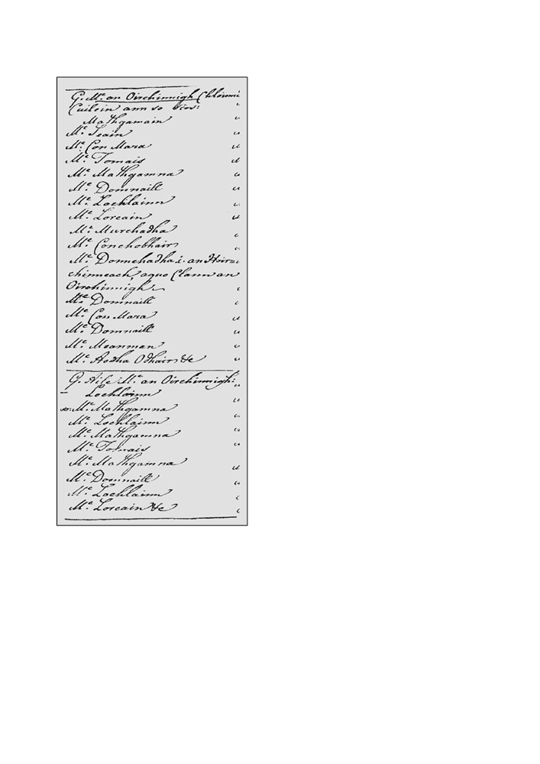

6

McEnerhiny genealogy: c.1588

LUKE McINERNEY

This genealogy connects Donnchadh to the
ruling lineage of the Mac Conmara; that is,
Donnchadh was the brother of Cúmhara Mac
Conmara, king of Uí Chaisín (d.1151).
Donnchadh also appears in the Book of
Lecan (c.1418) under the Mac Conmara
genealogy.³⁴ Other genealogies³⁵ including
the c.1588 genealogical text RIA Ms 23.H.22
sets down a full pedigree of the family and
claims that Donnchadh served as an
erenagh.³⁶ By calculating generation time-
spans a twelfth century date for Donnchadh is
plausible, placing him in a period of intense
ecclesiastical activity in Thomond. This time-
scale is also corroborated with the annalistic
obituary for Cúmhara Mac Conmara, reputed
brother of Donnchadh, killed in 1151 at the
battle of Móin Mór.³⁷ Other medieval
references to McEnerhinys occur in the 1309
battle of Kilgorey in the saga-text Caithréim
Thoirdhealbhaigh.³⁸ The description of the
sept in the text suggests an established
lineage at that time.
Several observations can be made from these
genealogical texts. First, they set down in
lineal form the main segment of the
McEnerhiny lineage. The names given are
presumably a succession of sept-heads,
(ceannfine) but there is no indication as to
what form of succession was in operation.
Second, the forenames in the genealogy can
be crossed-referenced to other sources.
Tomás, who was the common grandfather of
the rival branches of the McEnerhiny sept
39 and featured in the c.1588 genealogical text

³⁴ Kathleen Mulchrone (ed), The Book of Lecan: Leabhar Mór Mhic Fhir Bhisigh Leacain, p.434.
³⁵ For other genealogies that cite the origins of the Mac an Oirchinnigh see RIA Ms 23.N.12, pp.186-187; RIA Ms 23 H. 25
p.84; RIA Ms D i 3, f.74v; RIA Ms E iv. 4(a) f. 28. Also in published form see Analecta Hibernica: No.18, O’Clery Book of Genealogies, (ed) Seamus Pender, Irish Manuscripts Commission, Dublin Stationary Office, 1951, p.153.
³⁶ RIA Ms 23.H 22, p.11. This claim is repeated in an early nineteenth century scribal note and pedigree by Conchubhar
Mac In Oirchinne of Ballybaun in County Clare: RIA Ms 24.M.40 96i.
³⁷ Annals of the Four Masters, sub anno, 1151.
³⁸ Sean Mac Ruaidhri Mac Craith, Caithréim Thoirdhealbhaigh, pp.40-41 & p.138. The McEnerhiny lineage is variously
written in this text as ‘Clann an Oirchinnicc’ and ‘Clann àghmhar an Airchinne’ (warlike Clann an Airchinne).
³⁹ RIA Ms 23. H.22 p.11 (nineteenth century copy), reputedly compiled by Maoilín Óg Mac Bruaideadha in c.1588. The
name “Mathg[h]amain” at the top of the pedigree is Mahon (c.1548-1617) who features in the Chancery Bill in this
article, the son of Seán (John, d.1565). The junior lineage is represented by Lochlainn who was killed at Carrigoran in
1573 and who heads up the second list.

McENERHINYS OF BALLYSALLAGH 7

(RIA Ms 23.H.22) flourished in c.1460. According to an eighteenth century list of castle
builders Tomás mac Sheaán Mhic an Oirchinnigh is credited with erecting Dromoland
and Ballyconeely tower-houses.⁴⁰ A Tomás Mac an Oirchine is also mentioned in a folk-
story scribed in English and Irish by Conor Ryan in 1825 regarding the McEnerhiny
lands at Trinahow townland and Cowlclogher field in the vicinity of Shepperton House
in Ballysallagh West.⁴¹ The forename Tomás does not occur in the fifteenth century Mac
Conmara or Mac Fhlannchadh (McClancy) genealogies so its inclusion in the
McEnerhiny genealogy and appearance in other sources confer a degree of credibility
on these references. Taken together these references pin-point an individual
McEnerhiny, and for the most part can be considered historically plausible; genealogies
are especially valuable when they can be corroborated against the historical record.
Tomás, however, is not mentioned in surviving annals. But his descendants, who
clashed over the proprietorship of the sept-estate can be identified in the sixteenth
century inquisition material and their agnatic relationship is accurately recorded in the
c.1588 genealogical tract by Maoilín Óg Mac Bruaideadha.⁴²
Sept-estate
The location of the McEnerhiny patrimonial lands has caused confusion amongst authorities. The Rev. Patrick Woulfe and Edward MacLysaght incorrectly identified the sept-estate at the “parish of Ballysally” (sic) and at “Ballycally”, respectively.⁴³ Historical sources indicate the sept-estate comprised Ballysallagh East, Carrigoran, Corkanaknockaun and Clonconnell⁴⁴ which are clustered together on the western side of Kilnasoolagh parish. Further lands belonged to the sept in Clonloghan parish with a cluster of McEnerhiny freeholders recorded at Lisconor and Caherteige in 1641.⁴⁵ Other lands identified in 1641 include Ardbraghan in Kilmaleery parish,⁴⁶ Ballykilty in Quin parish,⁴⁷ Derrie and Maghery in Templemaley parish⁴⁸ and Kilnahon (part of Knocklatter [sic] Knockslattery) in Doora parish.⁴⁹

⁴⁰ That the c.1588 genealogy (RIA Ms 23.H 22, p.11) record him not as the son of Seán but the son of Mathgamain, a
margin of error must be considered. Tomás mac Sheaán Mhic an Oirchinnigh was recorded in two lists: one an
unreliable eighteenth century list by William O’Lionain in Standish Hayes O’Grady’s Catalogue of Irish Manuscripts in
the British Museum, and another eighteenth century list in the O’Gorman papers. See R.W Twigge, Materials for a
History of Clann Cuilein, Add Ms 39262, Twigge Collection Vol II (ff.326), p.225 and (referenced by Twigge) RIA Ms
24.D.10 (O’Gorman Papers, 18th century Ms). See Standish Hayes O’Grady, Catalogue of Irish Manuscripts in the British Museum, Vol.1, Oxford University Press, London, 1926, pp.68-75, pp.69-71.
⁴¹ While highly corrupted the story records the refusal of Tomás to grant land to St Catherine, supposed patroness of
Kilfintinan, Templemartin, Templecatherine and Kilnasoolagh, to erect a chapel. Tomás was cursed and died by
chocking on a morsel of chicken. According to Máire Ní Ghruagáin of Kilnasoolagh, the field known as Cowlclogher is
derived from Cabhail Clochair or convent ruin. Ms G 990 [Inchiquin Papers], “From a writing by Connor Ryan of Sixmilebridge”, dated May 11, 1825, National Library of Ireland. Also see Máire Ní Ghruagáin, “The Fair Monument” Tradraí, 2008, p.14.
⁴² RIA Ms 23.H22, p.11.
⁴³ Rev. Patrick Woulfe, Sloinnte Gaedheal is Gall: Irish Names and Surnames, Dublin, H. Gill & Son, 1923, p.309 and
Edward MacLysaght, Irish Families: Their Names, Arms and Origins, Irish Academic Press, Blackrock, Co. Dublin,
1985, p.108.
⁴⁴ R. Simington, Books of Survey and Distribution, Being Abstracts of Various Surveys and Instruments of Title, 1636-
1703, [County of Clare], IMC, Stationary Office, Dublin, 1949, pp.157-160.
⁴⁵ Ibid., p.169 & p.171. Totaling 457 statute acres.
⁴⁶ Ibid., p.163. Totaling 40 statute acres.
⁴⁷ Ibid., p.148. Totaling 601 statute acres with the entire townland under McEnerhiny possession. ⁴⁸ Ibid., pp.126 & 130. Totaling 211 statute acres.
⁴⁹ Ibid., p.131. Totaling 222 statute acres.

8 LUKE McINERNEY

The morphology of landholding among freeholding septs was an important factor in
the relationship between hereditary sept-lands, territorial hierarchies and ruling families.
In central-east Clare, the freeholding septs yielded a tribute to the Mac Conmara Fionn
at Dangan (Daingean Uí Bhigín) as their overlords and specific rent was paid out of
certain quarters to the Uí Bhriain kings, later Earls of Thomond.⁵⁰ Freeholding sept-
estates were not homogenous and populated exclusively by related-kin, rather they
comprised sub-tenants and labourers known in sixteenth century English sources as
‘churls’ and whose aggregated families are first encountered in the 1659 ‘census’ (ie
1660 Poll Tax).⁵¹ It was also not unusual that sept-lands had a mix of economic activity
such as cropping, pasture, transhumance grazing (‘booleying’) and, in the case of the
McEnerhiny lands at Ballykilty and Lecaroneighter, water-mills.⁵²
The McEnerhiny sept-estate was located in the Mac Conmara lordship of West Clann Chuiléin, or the Barony of Dangan-i-viggin as it was known in sixteenth century English sources. Documentary evidence suggests that the McEnerhiny sept-estate in the second half of the sixteenth century comprised three tiers of landholding. First, the ‘core’ lands that were held in common by the leading segment of the lineage (deirbhfhine) situated at Ballysallagh East, Carrigoran and Ballykilty. It is possible to distill from contemporary sources that these lands transferred between generations by partible inheritance. Shared occupation of the lands amongst McEnerhiny deirbhfhine kinsmen characterised settlement on these lands.
The frequency of re-distribution of the lands remains unclear, but evidence suggests
that local inheritance practices favoured seniority in landholding and redistribution may
have occurred on the death of a coheir. In addition to the ‘core lands’ small parcels of
lands situated nearby can be classified as comprising constituent parts of the core estate
lands. Corkanaknockaun adjacent to Ballysallagh East, Clonconnell next to
Kilnasoolagh and Lecaroneighter to the south of Ballykilty, fall into this category. In
aggregate these lands—totaling 1,551 statute acres⁵³—must have comprised the
demesne lands of the McEnerhiny sept. It is likely that an element of stability existed

⁵⁰ R.W. Twigge, Materials for a History of Clann Cuilein, Add Ms 39260, Twigge Collection, British Library, pp.180-186,
pp.185-186. Also see Luke McInerney, “The West Clann Chuiléin Lordship in 1586: Evidence from a Forgotten
Inquisition”, pp.49-51.
⁵¹ See Séamus Pender (ed) A Census of Ireland Circa 1659, IMC, Stationary Office, Dublin, 1939. The population totals
for the following were: Ballysallagh East (23), Ballysallagh West (41), Carrigoran (16), Kilnasoolagh (29), Treanahow
(9), Rathfolan (32) Ballykilty (10) Laccaroweightragh (14). These totals represent heads of households and should be
multiplied by 4 to ascertain approximate totals. Patrick Nugent argues the interrelationship between settlement and
population is closely related to the built environment in the late medieval period, evidenced by nucleation of
communities around tower-houses and parish centres. The arable land of Kilnasoolagh parish and the dense network of
tower-houses (around seven) resulted in a medium to high population evenly distributed. Patrick Nugent, “The
Interrelationship between Population and Settlement in County Clare in the Seventeenth Century: the Evidence from the
1659 ‘Census’”, in Clare: History and Society, Matthew Lynch, Patrick Nugent (eds.) Geography Publications, Dublin,
2008, pp.79-104.
⁵² On references to the water-mill at Ballykilty see, for the year 1606, James Frost, A History and Topography of the
County of Clare”, p.280 and the year 1635 when it was recorded “two ploughlands of Ballykilty, and the two mills
thereon standing”, Ibid., p.329. Also see the reference to “two mills” in the Court of Chancery bill: Chancery Bills:
Survivals from pre-1922 Collection, B. No.228, National Archives of Ireland. Two mills can be identified at Ballykilty in the 1656-58 Petty Map below.
⁵³ Acreage totals from the Books of Survey and Distribution. Only 52 statute acres were classified as unprofitable, mainly
identified as bog and waste, while 27 statute acres comprised Carrigoran lough.

McENERHINYS OF BALLYSALLAGH 9

around the core lands of the sept-estate from the fifteenth century and that the land-
holding matrix did not undergo significant change until the seventeenth century.⁵⁴
The second tier of landholding is more complex to identify but can be classified as
individually inherited land and generally under the proprietorship of an individual
freeholder. This land is of sixteenth century origin and probably did not have any
patrimonial connection; its status, therefore, is difficult to deduce. This included lands
mortgaged to McEnerhiny freeholders at Bohir Roger and Bradagh and at Dromoland in
c.1603, a grant of land in the same year at Rathfolanmore,⁵⁵ as well as a parcel of land at Shanaghcloyne in Ballynacragga.⁵⁶ Knockslattery in Doora parish also passed into the inheritance of the McEnerhinys by way of dowry inheritance.⁵⁷
The final tier of landholding that characterised the McEnerhiny sept-estate is more
difficult to identify. Ecclesiastical or ‘termon land’ attached to the bishopric of Killaloe
were farmed by hereditary tenants settled on church lands under the stewardship of an
erenagh. From a surviving inquisition of 1586 we know that Carrigoran, part of the
‘core’ sept-lands of the McEnerhinys, was regarded as belonging to the bishopric of
Killaloe, along with Kilnasoolagh townland. Evidence suggests that a McEnerhiny
freeholder occupied the church land at Kilnasoolagh in 1617, a point that we will return
to later. The implication is that the McEnerhinys may have retained their historic
function as an erenagh sept on these ecclesiastical lands, even though an examination of
the Papal Registers does not indicate an obvious hereditary ‘erenaghy’ in the parishes of
Kilnasoolagh and Kilmaleery.⁵⁸

54 The Court of Chancery bill estimates the value of Ballykilty, Ballysallagh beg (ie. Ballysallagh East) and Lecaroneighter
containing four quarters of land and two mills as £1000 in c.1600. In 1635 Mahon McEnerhiny (son of Mahon
mentioned in the Chancery bill) and his two ‘feoffees’ granted Giles Bowdens Ballysallagh East (two quarters) for £600.
James Frost, The History and Topography of the County of Clare, p.329.
55 See John Ainsworth (ed), The Inchiquin Manuscripts, No.983, pp.312-313 and No.1481, pp.504-505. Bohir Roger and
Bradagh were recorded in 1641 as joint lands comprising 65 plantation acres. In 1711 in a rent roll of Henry O’Brien, Earl of Thomond, the denomination was recorded as “Boherone als [ie alias] Newmarket and Bredagh 52:3:16 acres”, suggesting close proximity to the village of Newmarket-on-Fergus, probably on the Tomfinlough side. See the 1641 Books of Survey and Distribution, p.149 and Petworth House Archives, Chichester, “A rent roll of the estate of the Rt. Hon. Henry Earl of Thomond together with the sub-denominations in each lease and estimation of the value thereof. Delivered to the Rt. Hon. the Earl of Thomond, Anno 1711”, Ms 1707.
56 On the identification of Shanaghcloyne in Ballynacragga see John Ainsworth (ed), The Inchiquin Manuscripts, No.1046,
p.338 and also see James McEnerhiny’s claim to Shanaghcloyne as his inheritance in 1619 when it stated
“Shanaghcloyne in vill de Beallancraggy”. Petworth House Archives, Chichester, [Inquisition reciting the lands held by
Donough O’Brien, fourth Earl of Thomond], B.26.T.16, [last page - five rows from bottom of parchment].
57 On Kockslattery see Petworth House Archives, Chichester, “Tibbott McRicrard Confession in 1619 - touching my
L[or]ds right to Lands out of his possession about Belahinan” [“certain intelligence given by Tibbott mcRicrard of Moihmore the 24 May 1619”] No.122, (unsorted Bundle) C.13/35.
There appears to be a series of land dealings by McEnerhiny freeholders in the 1620s that included the ownership of the
lands of Cahirduffe in Ballynacraggra, Drominmuckilagh in the barony of Islands, and Caher-i-grady, Corcaghlana,
Rinelaheemore, Ranaghan in Ballysallagh West. Also mentioned were Craganepad and Kiltyneskeha in Ballysallagh
East and Bernegghy, a residence of Mahon which can be identified in Clareabbey parish. James Frost, The History and
Topography of the County of Clare, pp.328-330. On the location of Cahirduffe see James Frost, Ibid., p.295. On the
location of Bernegghy see Séamus Pender (ed) A Census of Ireland Circa 1659, Clareabbey parish where it is recorded
as “Bernegehy”.
58 Luke McInerney “Clerics and Clansmen: The Vicarages and Rectories of Tradraighe in the Fifteenth Century”, pp.15-
16. In nearby Tomfinlough parish, an ancient monastic site, the cómharba—or coarbship—was still remembered in 1622
when its office was recorded by John Rider, Protestant Bishop of Killaloe (ie.“in converbiatu de Tomfinloh”). This
suggests that the coarb and erenagh system was not extinguished by the Norman presence in the thirteenth century or
that it was reconstituted as part of the ecclesiastical economy after the collapse of the Norman colony. Philip Dwyer, The
Diocese of Killaloe from the Reformation to the Close of the Eighteenth Century, Hodges, Foster and Figgis, Dublin,
1878, p.136.
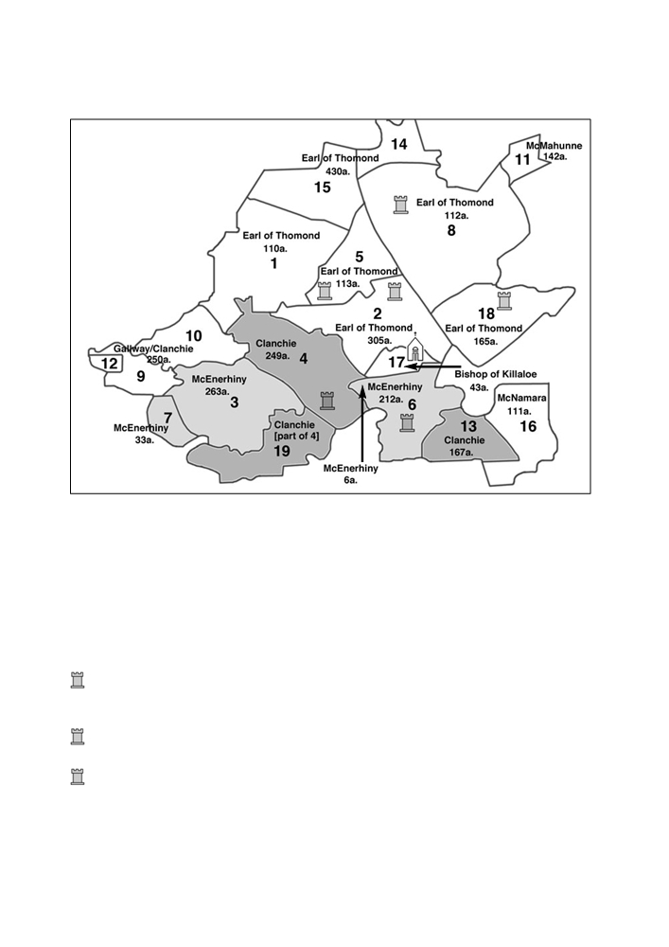

10 LUKE McINERNEY

Kilnasoolagh parish showing lands occupied by principal lineages in 1641⁵⁹

Landholding Matrix
Earl of Thomond [Barnabas]: 1,976a.
Clanchie [Mac Fhlannchadha]: 865a.
McEnerhiny Mac an Oirchinnigh]: 822a.
McMahunne [Mac Mathghamhna]: 227a.
Gallway [Mac Giolla Riabhaigh]: 200a.
McNamara [Mac Conmara]: 177a.
Bishop of Killaloe [Protestant]: 68a.
NB: Acreage converted from
plantation acres to statute acre.
Shaded area indicates main
McEnerhiny and McClancy
estates in the parish.

[NB: shaded area indicates core sept-lands of McEnerhiny and McClanchy lineages. Spellings as per 1641 Books of Survey and Distribution].
1. Ballygirreen 2. Ballynacragga 3. Ballysallagh East
4. Ballysallagh West (Castlekeale) 5. Ballyconnelly 6. Carrigoran
7. Corkanaknockaun 8. Dromoland 9. Ing East
10. Ing West 11. Kilkieran 12. Knockmurragha
13. Knocksaggart 14. Latoon North 15. Latoon South
16. Lisduff 17. Kilnasoolagh 18. Rathfolan
19. Trennahow
Dromoland: Castle builder — Tomás mac Sheaán Mhic an Oirchinnigh. Occupied by ‘Donogh mac moregh O bryene’ (1570); ‘Donogh mcMurrogh O brien’ (1574); William Starkey (1626).
Ballyconnelly: Castle builder — Tomás mac Sheaán Mhic an Oirchinnigh. Occupied by N/R (1570); ‘Tege mcMurrogh’ [O’Brien] (1574); N/R (1626).
Ballynacragga: Castle builder — Seaán mac Thaidhg ruaidh [Seaán mac Conchabhair Mhic Chon]. Occupied by N/R (1570); ‘Macneryheny’ (1574 - no forename); Richard Keatinge (1626).

⁵⁹ See John O’Donovan & Eugene Curry, The Antiquities of County Clare; Standish Hayes O’Grady, Catalogue of Irish
Manuscripts in the British Museum; R.W Twigge, Materials for a History of Clann Cuilein, Add Ms 39262, Twigge
Collection Vol II (ff.326); W. H. Bliss (ed.), Calendar of Entries in the Papal Registers relating to Britain and Ireland:
Papal Letters Vol. I AD.1198-1304, (London, 1893) p.326; R. Simington, Books of Survey and Distribution.


McENERHINYS OF BALLYSALLAGH 11

Ballysallagh West/Castlekeale: Castle builder — Conchabhar mac Sheaán [Mac Fhlannchadha]. Occupied by ‘Conoghor oig mac Clanchie, a brehon’ (1570); N/A (1574); N/A (1626). Evidence suggests this site was a fortified ‘hall-house’.
Carrigoran: Castle builder — Domhnail mac Finghin [surname unknown]
Rathfolan: Castle builder — Lochlainn mac Shíoda. Occupied by ‘Teig mac nemara’ (1570); ‘Donogh O’Brien’ (1574); N/A (1626).
Kilnasoolagh church: — Pre-Norman origins. First recorded in 1256 and united to the rural rectory of ‘Tradry’ [ie Bunratty].
Circumstantial evidence suggests that the sept has been based in the vicinity of
Ballysallagh since c.1400. Land transactions among McEnerhinys there occur up until
1655.⁶⁰ The historical record vindicates that the cluster of lands around Ballysallagh and
Ballykilty were the principal lands that constituted the patrimonial inheritance of the
McEnerhiny sept. It is not known when these lands were granted to them, but the
conventional historical view is that the Mac Conmara re-settled Tradraighe with allied
septs in the wake of the collapse of De Clare’s Norman colony in 1318.⁶¹ It is
reasonable to assume that both the McEnerhinys and McClancys, as offshoot septs of
the Mac Conmara ruling lineage, were settled in Tradraighe during the fourteenth
century. Interestingly, the McClancy maintained links from at least c.1400 to 1623—
which included landholding and petitioning for church benefices—with their kin-branch
at Killilagh parish in Corcomroe who served as hereditary brehons to the O’Briens.⁶²
As the chief abode of the McEnerhinys, Ballysallagh is divided into east and west,
with the latter division being occupied by the McClancy brehon sept. Ballysallagh has
Norman connections as the townland was held by feudal tenure by the free tenants
Nicholas de Interberg and Henry White in 1287.⁶³ By 1586 Ballysallagh East was
locally known as “Ballysallagh McEnerhine” presumably to differentiate it from the
western part of the townland.⁶⁴ Ballysallagh West comprised the McClancy estate and
fortified residence of Castlekeale. The McClancy’s principal residence was located
nearby at Urlanmor tower-house.⁶⁵ Nomenclature evidence from sixteenth century Sligo

⁶⁰ In 1655 Cunarra McInerhiny of Ballysallagh (along with Thomas Feild) entered into a lease with Daniel McNamara of
Ballynacragga. John Ainsworth (ed), The Inchiquin Manuscripts, No.1080, p.353.
⁶¹ James Frost, The History and Topography of the County of Clare, p.182.
⁶² On a Kilnasoolagh-Killilagh connection concerning McClancys see Papal mandates from 1405 and 1418 linking
‘Donatus Mclanchega’ (Donnchadh Mac Fhlannchadha) with the vicarage of Kilnasoolagh and the rectory of Glae in
Killilagh parish. According to Suim Cíosa Ua Briain (‘The Rental of Ó Bhriain’) the Mac Fhlannchadha were located at
Tuath Ghlae and held lands free from rent. See James Hardiman (ed.), “Ancient Irish Deeds and Writings Chiefly relating to Landed Property from the Twelfth to Seventeenth Century: With Translation, Notes and a Preliminary Essay”, Proceedings of the Royal Irish Academy, XV (1826) pp.36-43, p.42. See J.A Twemlow, Papal Letters, Vol.VI AD.1404-
1415, p.42 and Vol.VII AD.1417-1431, p.108. On landholding at Ballysallagh West by the McClancy lineage of Killilagh (including Boetius Clancy of Knockfinn) see Chancery Bills: Survivals from pre-1922 Collection, K (undated Bills). No.11, National Archives of Ireland.
⁶³ H.S. Sweetman, Calendar of Documents Relating to Ireland: 1285-1292, Liechtenstein, Kraus Reprint, 1974, p.207. In
January 2000 Martin Breen and Ristéard Ua Cróinín surveyed the ruins of Castlekeale at Ballysallagh West that formed
part of a late-medieval complex which comprised a large square bawn. The ‘long-house’ structure measured 32m long
and 8.4m wide and the ruined vaults suggest that there may have been a central tower. See Martin Breen & Ristéard Ua Cróinín, “Some Recently Located Tower-house Sites”, The Other Clare, Vol.24, 2000, pp.5-9, pp.7-8.
⁶⁴ R.W. Twigge, Materials for a History of Clann Cuilein, Add Ms 39260, Twigge Collection, British Library, pp.180-186,
p.182.
⁶⁵ The 1641 Books of Survey and Distribution, p.159 divide Ballysallagh West into four plough-lands, ie. Trincastlan,
Ranaghan, Trin McMikle and Chaghre Monghan. The first division refers to one-third of the caisleán - or castle - and
refers to the fields around Castlekeale which was then a McClancy fortified residence. Martin Breen, “A 1570 List of
Castles in County Clare”, p.133.
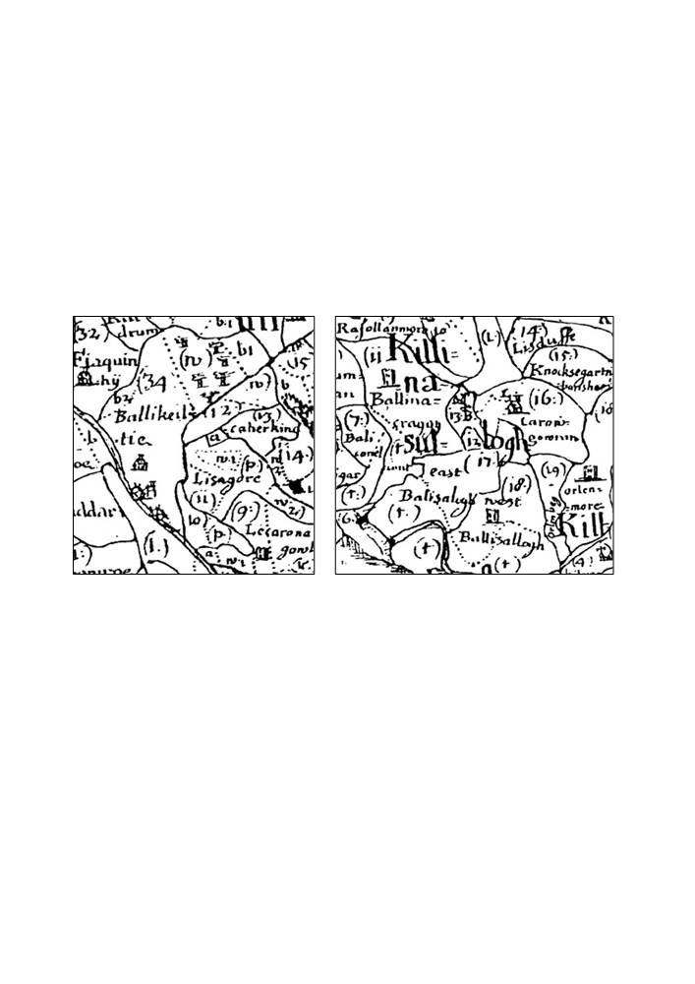

12 LUKE McINERNEY

points to stability amongst landholding septs in lordships, often over the course of centuries.⁶⁶ Similar nomenclature evidence is found in Thomond and the division “Ballysallagh McEnerhine” is a case in point.
Other chief centres of importance for the McEnerhiny include Ballykilty where two
water mills were located and also Ballynacragga where a tower-house was in the
possession by an unnamed member of the sept in 1574.⁶⁷ In terms of permanent
structures little is known but at Ballykilty and Carrigoran it is possible that fortified
structures existed prior to 1600.⁶⁸ Petty’s map of the barony of Bunratty dated 1656-58
shows that substantial structures existed in both of these townlands, and that the two
water mills located at Ballykilty since at least 1573 can be identified in the sketch. The
sketch also depicts tower-houses at Ballynacragga, Ballysallagh West (Castlekeale)⁶⁹
and Urlanmore:

Ballykilty with watermills Ballynacragga, Ballysallagh & Carrigoran

The 1586 inquisition into the lands of Seán Mac Conmara, Lord of West Clann
Chuiléin, records Ballysallagh West owing 7s 10d, while “Ballysallagh McEnerhine”
owed 6s 8d.⁷⁰ With the Composition Agreement in 1585 the Mac Conmara’s lordship
charges were replaced by a levy of five shillings on each land quarter, payable to the

⁶⁶ Mary O’Dowd, “Land Inheritance in Early Modern County Sligo”, Irish Economic and Social History, Vol.10, 1983,
pp.5-18, p.14.
⁶⁷ R.W. Twigge, “Edward White’s Description of Thomond in 1574”, p.80.
⁶⁸ An inscription above the fireplace in the old kitchen of Ballykilty House reads: “1614 John MacNamara and Onora
Clanchi bilded theis cheimnesis in the year of our Lord”. Whilst the fireplace may have come from a different site it is
possible that a pre-1600 structure existed on the site of the eighteenth century Ballykilty House. I thank Martin Breen for
his advice regarding the fireplace.
⁶⁹ Ballysallagh West may have been a fortified long-house structure with a tower, as evidence in the c.1675 Edenvale castle
survey of County Clare. The local name for the ‘castle’ is Castlekeale or An Caisleán Caol—the narrow castle—
suggestive of its long-house structure. The ruins of Castlekeale can be seen today. Brian Ó Dálaigh, Martin Breen &
Ristéard Ua Cróinín, “The Edenvale Castle Survey of Co Clare 1671-79”, North Munster Antiquarian Journal, Vol.45, 2005, pp.33-49, p.48.
⁷⁰ R.W. Twigge, Materials for a History of Clann Cuilein, Add Ms 39260, Twigge Collection, British Library, pp.180-186,
p.182.
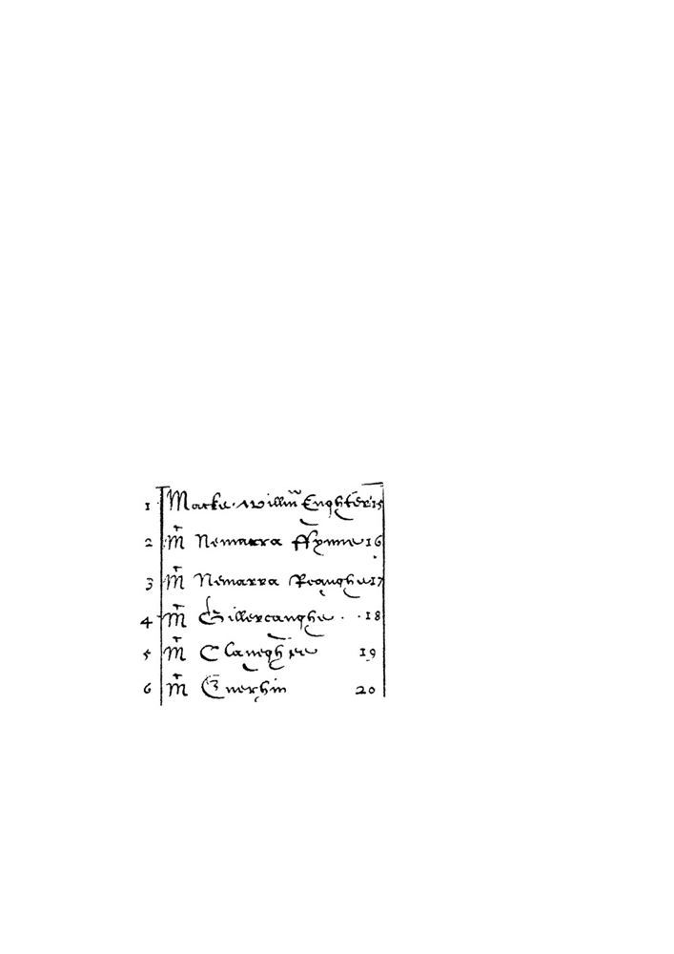

McENERHINYS OF BALLYSALLAGH 13

Earl of Thomond.⁷¹ Much information can be gleaned from surviving materials at
Petworth House and the 1624 inquisition post mortem of Donough O’Brien, fourth Earl
of Thomond, mentions those quarters that comprised the sept-land of the McEnerhinys:
…De et quarter terr in Rathmolanbegg quaique solid de et quatuor quarter terr
in Ballysallaghes vigint solid &et...de ex quarter terr in Carrigouran quinque
solid... .⁷²
(the quarter of land in Rathmolanbegg [pays] five shillings and four quarters of land in Ballysallaghes [ie. east and west Ballysallagh] [pays] 20 shillings…and the quarter of land in Carrigouran [pays] five shillings).
The foregoing recalls the Composition charge of five shillings and that the lordship over these lands was taken by the Earl of Thomond, being one of the reasons which prompted Seán Mac Conmara to complain that the Earl has usurped his right of lordship over lands in the barony of Bunratty.⁷³
Territorial magnates and heads of powerful Gaelic lineages as well as New-English settlers were rewarded in the 1585 Composition Agreement with lands free from composition charges. While not appearing in the final Composition Agreement signed by the main representatives of the Gaelic aristocracy on 14 August 1585 (excepting John McNamara Fionn), the McEnerhiny appear in an ancillary schedule to the final agreement. A note on “the names of all the macks and oes” of Connacht and Thomond and now part of the Carew Manuscripts lists the second-order lineages in apparent hierarchical order. The below is an excerpt of that document:

List of the
‘Mackes’ and ‘Oes’ of
Connacht and Thomond,
c.1585⁷⁴

⁷¹ A. Martin Freeman (ed), The Compossicion Booke of Conought, p.19. The Earl of Thomond and his heirs received five
shillings on 344 quarters of land in the barony of Dangan-i-viggan (ie Bunratty) as well as having six quarters of land at
the manor of Bunratty free from paying the composition charge to support the President of Connacht’s administrative
and military functions.
⁷² Inquisition Post Mortem of Donogh O’Brien, fourth Earl of Thomond, Petworth House Archives, Chichester, Ms.1141
[large rolled manuscript page five, top third of page).
⁷³ In 1589 Seán Mac Conmara complained to the English administration of the unfair nature of the composition agreement.
His grievance was related to the Earl of Thomond’s encroachment upon his lands and the Earl’s connection to the
influential houses of Kildare and Ormond. R.W. Twigge, Materials for a History of Clann Cuilein, Add Ms 39260,
Twigge Collection, British Library, p.192.
⁷⁴ J.S Brewer & W. Bullen (eds), Calendar of the Carew Manuscripts Preserved in the Archiepiscopal Library at Lambeth,
1867-1873, Carew MS 614, f.25. The preface to the list reads: “In consideration that by this composition not only all the
castles and lands belonging to their names; but also such castles and lands as they have of their own inheritance, are to
be confirmed by her Maj. Letters patents to them and their heirs in English succession” [spelling modernized].
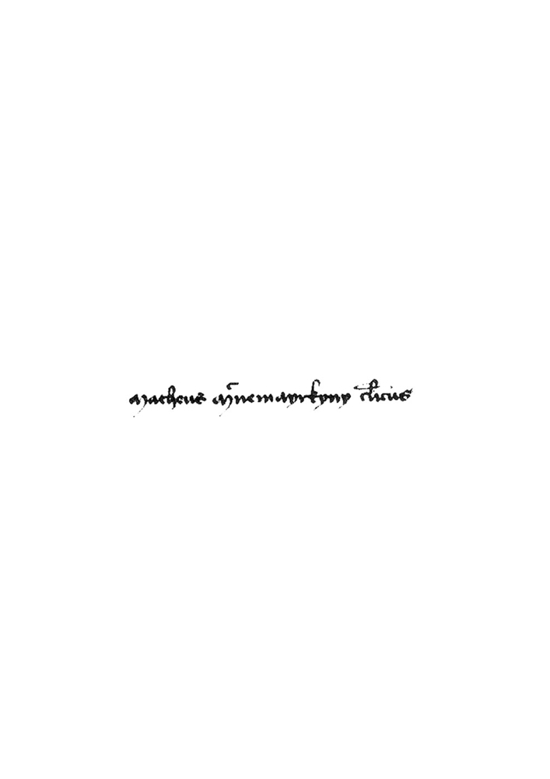

14 LUKE McINERNEY

The list begins with “Macke William Eighter” followed by “Mc Nemarra ffynne” (Mac Conmara Fionn) scribed above the following sept-lineages: “Mc Nemarra Reoughe”, (Mac Conmara Riabhach) “McGillereaughe”, (Mac Giolla Riabhaigh) “McClaneghee” (Mac Fhlannchadha) and “McEnerhin” (Mac an Oirchinn). The tripartiate indenture component of the Composition Agreement cajoled the leading Gaelic gentry to be fully enmeshed in feudal land tenure. That the McEnerhiny featured in a background document associated with the Composition serves as an acknowledgement of their relative importance in the landholding hierarchy.
Ecclesiastical Connection
The fifteenth century Papal Letters (1396-1521) and petitions known as Regesta
Supplicationum record McEnerhiny clerics being appointed the vicarages of
Kilnasoolagh, Kilmaleery, Kilfintanan, Clonloghan and Bunratty and the rectories of
Quin, Bunratty, Drumline and Tymorlogyg.⁷⁵ McEnerhiny clerics are first recorded in
the published Papal Registers in 1411 when Matthew Macmeyrcheyn (Mathghamhain
Mac an Oirchinn) was recorded as holding the rectories of Quin and Bunratty and
petitioned to be assigned the vicarage of Kilmaleery.⁷⁶ A petition from 1419 indicated
that he held the simple rectories of Tymorlogyg and Drumline and that he sought to hold
Kilnasoolagh vicarage.⁷⁷ Matthew was described as the ‘offspring of a noble lineage’
(de nobili genere procreatus existit) as are other McEnerhiny clerics recorded in the
Papal Letters in the vicinity of Kilnasoolagh and Kilmaleery parishes.⁷⁸ The original
petition from Killaloe to the Roman Curia scribed his name on parchment in 1419 thus:

Matheus Macnemayrkyny cl[er]icus⁷⁹

An even earlier petition is recorded amongst the Papal Letters of Clement VII of
Avignon during the uncertain time of the Great Schism. The petition, one of two
published for Killaloe diocese, stated that ‘Dermicius Macenkargyd’ (Diarmaid Mac an

⁷⁵ See Luke McInerney “Clerics and Clansmen: The Vicarages and Rectories of Tradraighe in the Fifteenth Century”.
⁷⁶ Twemlow, Papal Letters Vol. VI AD.1404-1415, London, 1904, pp 256-7. The 1411 mandate states that he was of ‘ducal
race’ and in his nineteenth year placing his birth as 1392. Other mandates refer to Matthew’s knowledge of Latin and
studies of canon law and his death c.1422 aged thirty. Life expectancy among landed elite in Gaelic Ireland was affected
by high morality rates and death through fighting, resulting in a small number of male heirs. The well-fed notables of
dominant septs had a strong incentive to vigorously reproduce sub-branches to acquired territories and subinfeud vassals,
giving greater reach to the parent lineage. Mahon McEnerhiny ceannfine of the sept died in 1617 aged 69. Life
expectancy of notables was short and genealogical material confirms that two or three sons per family was the usual size
due to high male mortality. A document from c.1635 shows that the sister of James McEnerhiny, Oona Ny Inheriheny,
was married to John McNamara of Rineanna who died during the lifetime of his father Cuvarra and two sons Daniel and
Shane, leaving Oona windowed. Given high male mortality rates this picture of a husband dying before his father and
wife must have been familiar. Petworth House Archives, Chichester, [on back of a land deed of David O Ruddan] PHA
C.13.35; Mary O’Dowd, Power, Politics and Land: Early Modern Sligo 1568-1688, p.71-72. On Matthew the cleric see
Luke McInerney “Clerics and Clansmen: The Vicarages and Rectories of Tradraighe in the Fifteenth Century”, pp.10-12.
⁷⁷ ASV Regestum Supplicationum 129f. 63.
⁷⁸ Ibid. For a similar petition by the same cleric see ASV Regestum Supplicationum 131, 34-34v. In 1443 Dermit
Macinnercheny was described as of “noble race” and in 1483 Laurence Macnoyerhyne was described as “noble birth by
both parents”. Belonging to a landed dominant lineage of ‘noble’ status conferred legitimacy on a cleric and the awarding
of benefices. See J.A Twemlow, Papal Letters Vol. VIII AD.1471-1484, p.131 Vol.IX AD.1431-1447, pp.353-354.
⁷⁹ See ASV Regestum Supplicationum 129f. 63. This is also excerpted and published in Special List 43 available at the
National Library of Ireland Manuscripts Reading Room. In terms of date, this excerpt appears under the chapter ‘Second
Year of the Pontificate of Martin V, 21 Nov 1418 - 20 Nov 1419’.

McENERHINYS OF BALLYSALLAGH 15

Oirchinnigh) held the perpetual vicarage of ‘Kylomsulach’ (Kilnasoolagh) and rectory of Uí Cormaic (parishes of Drumcliff and Kilmaley) in 1382, but was to yield the latter to a Mac Craith who was probably connected to the Mac Craith hereditary church family of Clareabbey.⁸⁰
The Papal Letters reveal that the McEnerhiny sept supplied a steady stream of clerics
to local benefices; this is not surprising considering that the McEnerhinys were an
established landholding sept. However, it is unclear whether the benefices at
Kilnasoolagh and Kilmaleery were in the possession of either a coarb or erenagh sept.
Whether the ancient coarb and erenagh system—once a component of the Gaelic
ecclesiastical economy—was still extant after the settlement and collapse of the Norman
colony cannot be distilled from the Papal Letters. The presence of church lands at
Carrigoran and Kilnasoolagh⁸¹ and those recorded as ‘in ecclesiastical fee’ in Clonloghan
which belonged to the Bishop of Killaloe, suggests the occupancy of episcopal tenants,
possibly under the stewardship of an erenagh.
Carrigoran formed the ‘core’ sept-lands of the McEnerhiny lineage in the sixteenth
century. Its inclusion in the 1586 inquisition as belonging to the bishopric of Killaloe
links the McEnerhinys to termon lands. By piecing together references in the historical
record we can identify James McEnerhiny whose father was a cleric and himself a
literate man constituting a link between the McEnerhiny lineage and termon lands of
Kilnasoolagh parish.⁸² Documentation from Petworth House Archives identifies James
in the service of the fourth and fifth Earls of Thomond and active on local inquisitions.⁸³
In 1617 James is recorded as ‘detaining’ the church lands at Kilnasoolagh from Bishop
Rider. The survey of church lands in the 1661 Bishop Worth’s Account Book notes:
1 Quarter Arable Pasture 43 [acres], the Civil Survey agrees. This Quarter was
released to the Bishop of Killaloe by James mac Enernie 6 Jan: 1617, N[ew]
S[tandard]. And I cannot find any lease made thereof since to the said James or

80 I wish to thank Brian Ó Dálaigh for bringing this reference to my attention. See Charles Burns, “Papal Letters of
Clement VII of Avignon (1378-94) relating to Ireland and England”, Collectanea Hibernica, No.24, 1982, pp.7-44, p.29.
The holding of Kilnasoolagh vicarage confirms this cleric, despite the mangled surname, as a kinsman of the
McEnerhiny sept of Kilnasoolagh.
81 See R.W. Twigge, Materials for a History of Clann Cuilein, Add Ms 39260, Twigge Collection, British Library, pp.180-
186, p.185. The Composition Book of Connacht (1585) also mentions the presence of termon lands in Tradraighe —
q.v.“Toewoghtragh Tradry consisting of 33 quarters, whereof one quarter beareth Chiefry to the Bishoprick of Killalow”. Toewoghtragh Tradry (Tuath Uachtarach Tradraighe) or upper Tradraighe comprised Kilnasoolagh and Tomfinlough parishes. A. Martin Freeman (ed), The Compossicion Booke of Conought, p.8.
82 See John Ainsworth (ed), The Inchiquin Manuscripts, No.983, pp.312-313 and No.1481, pp.504-505. These references
relate to the lands held by Conor O’Brien of Dromoland on his death in 1603 with the latter mentioning “John
McEnerhyny, ‘prist’ and James his son, for which they have a quarter of Dromolin in mortgage”. The former reference
refers to a grant to James McEnerhine of 4 acres in Rathfolan by Conor O’Brien prior to 1603. In 1619 in an inquisition
into the lands of Donough O’Brien, fourth Earl of Thomond, James claimed several lands as his inheritance, including
“quatron acr measure hibernor in Rathfoylane” [4 acres of Irish measure at Rathfolan] linking him to the c.1603 grant
and therefore son of John McEnerhyny the cleric. In 1619 James, who was residing at Ballysallagh, also claimed 1
cartron of land at Shanaghcloyne (Ballynacragga) as his inheritance. These references link James to John the cleric and it
is likely that James was the same James who translated deeds from Irish to English at Limerick 1611 along with the
New-English settler Hugh Brickdall. In 1619 James signed his name in legible English on a deed concerning David and
Donell O Ruddan and scribed next to William Brickdall, presumably the son of Hugh. See Petworth House Archives,
Chichester, [Inquisition reciting the lands held by Donough O’Brien, fourth Earl of Thomond], B.26.T.16, [last page -
five rows from bottom of parchment]; Petworth House Archives, Chichester, PHA C.13.35 and James Hardiman (ed),
“Ancient Irish Deeds and Writings Chiefly relating to Landed Property from the Twelfth to Seventeenth Century: With
Translation, Notes and a Preliminary Essay”, pp.50-51.
83 See John Ainsworth (ed), The Inchiquin Manuscripts No.950, p.299, No.980, pp.308, No.982, p.311. Petworth House
Archives, Chichester, PHA C.13.35; Petworth House Archives, Chichester, “A Register made by the Right Honorable Barnaby Earle of Thomond of all his Evidences and writings att Bunratty [Anno.1640]”, PHA C.13.27, No.56 , No.114 and No.90. Petworth House Archives, Chichester, “John McCloone his relac’on touching Ballimacloone” and “James McEnnerhiny his relac’on touching the above land”, PHA Ms 3911.

16 LUKE McINERNEY

any other, yet it was enjoyed by your[self] at the rent of £3 yearly. But 6 Feb. 1636 Bishop Lewis Jones sealed a lease thereof to William Price who 11 Feb. 1636 entered the dwelling house of the said James mac Enerinagh & demanded possession thereof but being refused by the said James[,] Connor Malloine yeoman took a clod of earth & delivered it to the lessee as possession of the said land.⁸⁴ [spelling modernized and contractions expanded]
This reference confirms James’ possession of Kilnasoolagh termon lands where he gave
his residence at a 1611 inquisition.⁸⁵ It also suggests that James was alive in 1636, a
point that is confirmed in his lodged suits at the Chancery Court.⁸⁶ James’ possession of
this land, coupled with the fact that his father was a cleric, infers a historical link
between the McEnerhiny sept and the termon lands of Kilnasoolagh parish. Other
Petworth House sources points to James holding, as his partible inheritance, parts of
Knockslattery and Ballykilty in c.1619 identifying him closely with the leading
McEnerhiny branch.⁸⁷ Corroborating evidence pointing to the McEnerhiny sept-lineage
exercising the role of hereditary erenaghs in the sixteenth century is, however, absent.⁸⁸
Circumstantial evidence may be found in the bardic poem Créd fá seachnaim síol
Aodha? compiled possibly in c.1571. The poem recounts the ecclesiastical origin of the
McEnerhiny sept, referring to their descent from Donnchadh (“deighshíol Donchadha
meic Domhnaill”) and their role as an erenagh lineage (“síol ádhbhor an oirchinnigh”).⁸⁹
The termon lands of Kilnasoolagh were still extant in 1767 and recorded in Thomas Hewitt’s map of Newmarket as “Bishopsland”.⁹⁰ Despite the uncertainties surrounding the role of the McEnerhiny sept at the termon lands of Carrigoran and Kilnasoolagh any vestige of a Gaelic ecclesiastical economy, including the presence of erenaghs, would have been removed by the Protestant Bishop Rider in the early 1600s.
McEnerhiny land dispute: 1565-1632
New information has provided useful detail concerning a dispute over the core
McEnerhiny sept-lands. The dispute culminated in violence in 1573. The dispute was
between two branches of the sept who shared a common grandfather. The centrality of
land proprietorship to personal security and wealth meant that the stakes were high

⁸⁴ Ms 1777, Typescript copy of a survey of lands in the diocese of Killaloe made for Bishop Worth, 1661, (Rev) James B.
Leslie, pp.11-12.
⁸⁵ See John Ainsworth (ed), The Inchiquin Manuscripts, No.980, pp.308-309.
⁸⁶ It would appear James was also alive in 1641 see R.W. Twigge, Materials for a History of Clann Cuilein, “The Names of
the Principal Irish Gentry Accused of Crimes Various Crimes in the Depositions of the Protestant Settlers in Co Clare:
1642-1654” Add Ms 39260, Twigge Collection, British Library, Vol.II, f.314 [deposition of William Culliver, 1641].
Also see Court of Chancery Bill Books: 1633-1640, Vol 1, National Archives of Ireland [microfilm], p.75, pp.165-166.
⁸⁷ See Petworth House Archives, Chichester, [“Information about Land out of my Lords hands, No.32, Wm Brickdall”] no
date, C.13.35. The document reads: “The half quarter of Cnock I Slattry with the mill adjoining to the lands of
Dromollen and the half quarter of Ballykilty called Leacerrone Iraghteragh are the inheritance of James Mc Inernyny, of
which James Mc Innerreny was found guilty of man slaughter for the killing of James Dixon one of Sir Robbert
Mcleanan’s company. Sir Rowland Dellahoyde being foreman of the petty Jury that found the said James guilty”
[modernized spelling]. In 1641 Leacerrone Iraghteragh (ie.Lecaroneighter) was in the possession of John McNamara of
Moughane while the Earl of Thomond had managed to assert his original ownership rights over part of Kilnahon adjoined to Knockslattery (Knockclatter). R. Simington, Books of Survey and Distribution, p.131 & p.152.
⁸⁸ On this point see Luke McInerney “Clerics and Clansmen: The Vicarages and Rectories of Tradraighe in the Fifteenth
Century”.
⁸⁹ See RIA Ms 784 (q.v. Ms 23.G.9) and the author’s article in this edition of the North Munster Antiquarian Journal: Luke
McInerney, “A sixteenth century bardic poem composed for Seán Mac Conmara, Lord of West Clann Chuiléin”. See this
article for a translation of the verses quoted here.
⁹⁰ See Henry Hewitt’s 1767 map in the National Library of Ireland Ms 21.F.150 Inchiquin Manuscript Maps. Copy
reproduced by Mary O’Leary and supplied by Máire Ní Ghruagáin of Kilnasoolagh.

McENERHINYS OF BALLYSALLAGH 17

when landholding was disputed amongst sept members. The survival of inquisitions post mortem and a Chancery Court bill provides further context to events and adds to our understanding of how inheritance operated amongst landholding sept-lineages in the sixteenth century lordship of West Clann Chuiléin.
The ultimate function of the inquisition post mortem system was to determine what revenues, if any, escheated to the crown on the death of a landed freeholder. Under this system, the re-granting of a freeholder’s lands to his heirs acted as a powerful means of extending social control and political patronage. On the 16 May 1579 the first of three inquisitions post mortem were taken regarding the death of sept-head John McEnerhiny (Seán Mac an Oirchinnigh). The death of John McEnerhiny at Dromoland on 5 November 1565 sparked a land dispute amongst two factions of the McEnerhiny deirbhfhine who shared a common grandfather, Tomás. Tomás and his descendants are scribed in a genealogy compiled in c.1588 probably for the purpose of supporting the land claims of the senior branch of the lineage as the genealogy records both rival branches, but gives prominence to the senior branch.⁹¹
Pedigree of the McEnerhiny deirbhfhine cited in the 1579, 1606 & 1632 inquisitions⁹²
Tomás McEnerhiny
Senior branch Junior branch

Con Mara Mahon
John (d.1565; original Loghlen
of Ballysallagh & Ballykilty) Mahon (d.1572; held Ballysallagh,
Mahon (b.1548-d.1617) Ballykilty & Carrigoran)
John (heir of Mahon) Loghlen (d.1573 - murdered at Carrigoran)
Donough (b.1570, appeared in 1606
Inquisition Post Mortem)

According to the c.1588 genealogy the two sons of Tomás—Con Mara and Mahon—
were progenitors of rival branches of the sept that claimed the lands of Ballysallagh and
Ballykilty on the death of John in 1565. Circumstantial evidence in the 1579 inquisition
points to the family of John as the incumbent lineage on the sept-lands at that time, a
position they probably held along with the position of sept-head in recognition of their
status as “the true owner[s]” of the lands according to the 1606 inquisition.⁹³
New evidence from a recently found document from the Court of Chancery provides
rare detail on the capacity for violent conflict between competing branches of the sept.
While the background to the McEnerhiny land dispute has been noted elsewhere,⁹⁴ the
inquisition material recorded in abstract form by James Frost is recounted here:

Inquisitions post mortem, taken at Ennis, on the 16th of May, 21st year of Elizabeth
[1579], before John Crofton, finds that John MacInerney, late of Ballykilty, died on

⁹¹ RIA Ms 23.H22, p.11.
⁹² All names have been anglicised and sourced from the 1579, 1606 and 1632 inquisitions post mortem in James Frost, The
History and Topography of the County of Clare, p.269 & p.280 and from the c.1588 pedigree of the Mac an Oirchinnigh:
RIA Ms 23.H22, p.11.
⁹³ James Frost, The History and Topography of the County of Clare, p.280
⁹⁴ See Luke McInerney, “Survey of the McInerney Sept of Thomond: Part II”, The Other Clare, vol. 32, 2008, pp.27-29.

18 LUKE McINERNEY

the 5th of November, 1565, seized in fee of Ballysallagh and Ballykilty; that Mahone MacInerney, aged 17, at his father’s death, is the son and heir of said John; finds that Mahone, son of Loghlen, and Mahone’s son, Loghlen the younger, both relations of John, had laid claim to his lands and appropriated them to their own use for thirteen years past.⁹⁵
Inquisitions post mortem, taken at the Windmill, on the 13th of March, 1606, by
Humphrey Wynch, finds that Mahone, son of Loghlen MacInerney, died at
Ballysallagh, on the 12th of November, 1572, being then owner in fee of
Ballysallagh, Ballykilty with its water-mill, and of Carrigoran, and leaving his
son Loghlen his heir-at-law. This son died at Carrigoran on the 14th of
November, 1576, leaving his son Donogh, then aged six years, but now of full
age, as his heir; finds that Mahone, son of John MacInerney, disputes the right of
his cousin to the ownership of these lands, alleging that his father John, who was
the true owner, had died at Dromoland, on the 5th of November, in the 7th year
of the reign of Queen Elizabeth, leaving him, the said Mahone, his son and heir.⁹⁶
A subsequent Inquisition post mortem, taken in 1632, finds that Mahone had been in possession, and that he died about the year 1617, leaving a son John to succeed him, a man then of full age.⁹⁷
Following the death of John in 1565 his son Mahon was sidelined by his cousins who
appropriated the lands. It may have been the intention that prior to the death of John he
placed his estate in trust to senior kinsmen of the junior branch of the family in the
expectation that proprietorship would return to his under-aged son Mahon. Mahon was
displaced from Ballysallagh by his cousins after 1565 and in the intervening period to
1573 he probably resided on his mother’s dowry land at Knockslattery in Doora parish.⁹⁸
Probably using Knockslattery as a safe homestead, Mahon returned in February
1573 at the age of 25 to reassert his position as heir to John and sept-head. On 12
November 1572 the eldest representative of the junior McEnerhiny branch, Mahon son
of Loghlen, died at Ballykilty and was then the owner of the core sept-lands of
Ballysallagh, Ballykilty with its water-mill, and Carrigoran leaving a son Loughlen as
his heir.⁹⁹ In a quick succession of events the deposed Mahon returned to Ballysallagh
along with a galloglass mercenary Molmorry McEdmond, his brother-in-law, and killed
Loughlen, the new incumbent on the sept-lands on 1 February 1573 (recte 1574).

⁹⁵ James Frost, The History and Topography of the County of Clare, p.269.
⁹⁶ Ibid., p.280.
⁹⁷ Ibid.
⁹⁸ A document dated 14 May 1619 confirms that the half quarter of Knockslattery was the original property of Conor
O’Brien, third Earl of Thomond, who mortgaged them to Richard Roe McMolery, the brother of Mahon McEnerhiny’s
mother. Presumably Richard Roe passed the land on as a dowry to Mahon’s mother. In 1619 Tibbott, son of Richard
Roe, disputed Mahon’s possession of the townland on the basis that it “descended unto him in right of his mother, sister
to Riccard Roe”. Petworth House Archives, Chichester, “Tibbott McRicrard Confession in 1619 - touching my Lds right
to Lands out of his possession about Belahinan” [“certain intelligence given by Tibbott mcRicrard of Moihmore the 24
May 1619”] No.122, (unsorted Bundle) C.13/35. Mahon remained in possession of Knockslattery until his death in 1617
and possibly settled a grandson Loughlin there. In 1641 Loughlin McEnerhiny held Kilnahon, a townland joined to
Knocklatter (sic Knockslattery). Mahon’s claim to the land as inheritance from his mother may have been false as the
land probably would have reverted back to his mother’s family after her death. See Mary O’Dowd, Power, Politics and Land: Early Modern Sligo 1568-1688, p.73 also see R. Simington, Books of Survey and Distribution, p.131.
⁹⁹ James Frost, The History and Topography of the County of Clare, p.280.
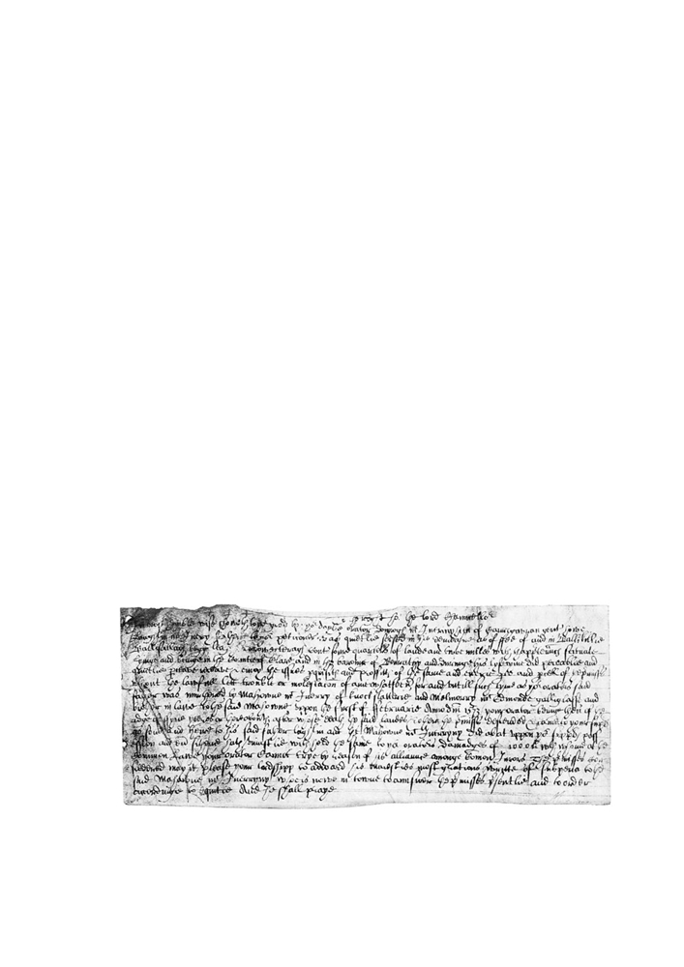

McENERHINYS OF BALLYSALLAGH 19

The inquisitions transcribed by James Frost do not record this event. The 1606
inquisition incorrectly states that Loughlin died at Carrigoran on 14 November 1576,
leaving a son Donough. Inconsistencies with the dates could be due to editing by Frost
or by difficulty in reading the original document. Donough pursued his claim to the sept-
land by initiating a suit in the Court of Chancery—under the law of equity—as he could
not get redress under common law due to Mahon’s alliance with the jurors on local
inquisitions.¹⁰⁰ Donough’s Court of Chancery (undated) bill recounts the events in full:
To the right hon. the lord Chancellor.
In most humble wise showeth to your good honour your daily orator Donnough
McInerinyhein of Carrgauran gent., how Laughlin McInery father to your
petitioner, was quietly seised in his demesne as of fee of and in Ballikillie,
Ballisallaghbegg, Leaghkearrowegteragh containing four quarters of land and
two mills with the appurtenances situate, lying and being in the County of Clare
and in the barony of Bunratty and during his lifetime did peaceably and quietly
proceave[?], receive and enjoy the issues, perquisites and profits of the same and
every part and parcel of the premises without the lawful let, trouble or molestation
of any whatsoever, for and until such time as your orator’s said father was
murdered by Mahowne McInerry of Knockslatterie and Malmorry McEdmonde
galliglass and brother in law to the said Mahowne upon the first of February AD
1573 [recte 1574] your orator being then of age five years or thereabouts after
whose death the said lands and other the premises descended and came to your
supplicant as son and heir to his father Laughlin and that Mahowne McInnerryny
did abate upon your supplicant’s possession and ever sithence [since] hath
unjustly withheld the same to your orator’s damages of £1000, with whom at the
common law your orator cannot try [ie. trial] by reason of his alliance among
common Jurors. The premises considered may it please your lordship to award
his majesty’s most gracious writ of subpoena to the said Mahown McInerryny
who is now in town to answer the premises presently and to order according to
equity due he shall pray.¹⁰¹ [modernized spelling]

Original Court of Chancery Bill, c.1590-c1606¹⁰²

¹⁰⁰ Donough must have been of full age when he filed suit at the Court of Chancery. This would place the lodgment of the
bill between c.1590 to c.1606.
¹⁰¹ Chancery Bills: Survivals from pre-1922 Collection, B. No.228, National Archives of Ireland.
¹⁰² Chancery Bills: Survivals from pre-1922 Collection, B. No.228, National Archives of Ireland.

20 LUKE McINERNEY

From the Chancery bill we can see that Loghlen, as the representative of the junior
branch, held the lands of “Ballikillie, Ballisallaghbegg, Leaghkearrowegteragh
containing four quarters of land and two mills in the county of Clare” in 1573 (recte
1574). The involvement of Molmorry McEdmond,¹⁰³ who was described in the
Chancery bill as a “galliglass” mercenary was probably of the McSweeny galloglass
sept who settled in Co Cork on the MacCarthy demesne lands in the fifteenth century.
Mahon’s relationship with this McSweeny galloglass is uncertain, though Mahon’s
pardon for rebellion in 1577 points to a possible connection to rebellious activity with
the Earl of Clancare (Mac Cárthaigh Mór) and his McSweeny galloglass retainers.¹⁰⁴
The employment of an armed mercenary by Mahon points to the retention of Gaelic
military service septs in Thomond prior to their abolition under an agreement with the
Earl of Thomond concluded at Windsor Castle in 1577.¹⁰⁵
On the killing of his rival Loghlen, Mahon seised the sept-lands of Ballysallagh and
Ballykilty, displacing the junior branch of the family.¹⁰⁶ As Mahon had effective
possession of the core sept-lands from 1573, it is reasonable to link him with the c.1588
pedigree written by hereditary chronicler and genealogist, Maoilín Óg Mac
Bruaideadha, which descends to “Mathgamain [Mahon] Mac an Oirchinnigh”. This
pedigree served as a contemporary confirmation of his position as senior representative
of Clann Mhic an Oirchinnigh.¹⁰⁷
In 1577 Mahon was recorded as at Ballykilty¹⁰⁸ and in 1589 at Ballysallagh,¹⁰⁹
indicating that he remained in full possession of the McEnerhiny sept-estate. Mahon’s
recording in the 1586 inquisition into the land holding of John McNamara Fionn, Lord

¹⁰³ A search of the sixteenth century Irish Fiants identified one possible individual - “Moylmory mcEdmond McSwyne of
Castleton, yeoman” in 1573. This contemporary recording is probably related to rebellion in Desmond (Castleton could
be either in Kinalea or Imokilly baronies in Co Cork) rather than rebellion in Thomond. The reference to Moylmory
McEdmond McSwyne suggests that this is potentially the same galloglass who aided Mahon in 1573 and Mahon’s
pardon in 1577 in connection to rebellion in Desmond further illustrates his (kinship?) links to that lordship and his
ability to employ mercenary retainers. See The Irish Fiants of the Tudor Sovereigns, Fiant 2254, pp.291-292. A branch
of the McSweeneys can also be identified in Kiltoraght parish in Corcomroe barony where a descendant ‘Moylemury
McSwyny gent.’ was recorded in the 1659 ‘census’. Séamus Pender (ed) A Census of Ireland Circa 1659, Kiltoraght
parish.
¹⁰⁴ See The Irish Fiants of the Tudor Sovereigns, Fiant 3152 p.430.
¹⁰⁵ The State Papers of Ireland record that on 15 February 1574 around 300 Scots (‘redshank’ mercenaries), 700
galloglass, harquebusiers and kern camped at Clann Chuiléin making much commotion and that the local inhabitants
fled to Limerick with their cattle. The presence of these mercenaries was on account of the rebellion of the Earl of
Desmond for whom they came to aid, indicating the recourse to large scale violence in the late sixteenth century and the
ready employment of mercenary soldiers. Calendar of State Papers, Ireland, Tudor Period 1571-1575, p.506. On the
discontinued galloglass see J.S Brewer & W. Bullen (eds), Calendar of the Carew Manuscripts Preserved in the
Archiepiscopal Library at Lambeth, [1575-1588], Carew Manuscripts, Longmans, Green, Reader and Dyer Publishing,
London, 1868, p.116.
¹⁰⁶ Donough, the son of the murdered Loughlen, may have continued to reside nearby at Carrigoran as the Chancery bill
read: “Donnogh Mc Inerinyhein of Carrigauran, gent”. Donough was born around c.1568-c.1570 and was alive at the
time of the 1606 inquisition. His sons may have settled on land further south at Caherteige where Donogh mcDonogh
and Murtagh mcDonogh McEnerhiny were freeholders in 1641. See Mary O’Dowd (ed), Chancery Bills: Survivals
from pre-1922 Collection, B. No.228, National Archives of Ireland; R. Simington, Books of Survey and Distribution,
p.171.
¹⁰⁷ R.W Twigge, Materials for a History of Clann Cuilein, Add Ms 39266, Twigge Collection, p.315 & p.317. Also see
RIA Ms 23.H22, p.11.
¹⁰⁸ The Irish Fiants of the Tudor Sovereigns, Fiant 3152, p.430 [Mahowne McShane McInErrihine of Ballykilly, gent]. ¹⁰⁹ Ibid., Fiant 5401, p.96. [Maghowne McInerinn of Ballesolloghe, gent].
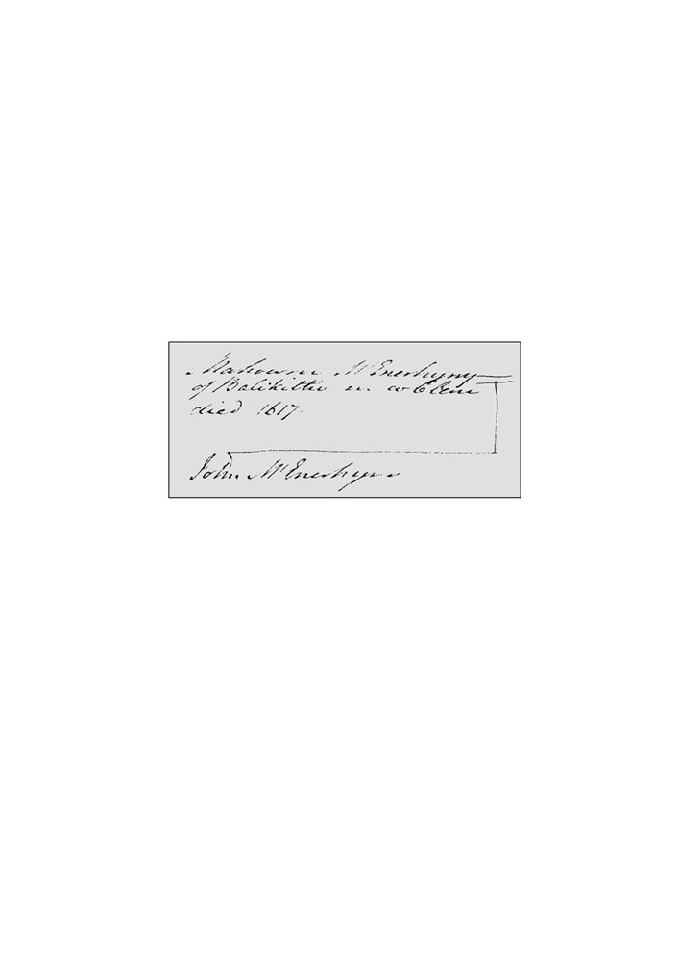

McENERHINYS OF BALLYSALLAGH 21

of West Clann Chuiléin, points to him as the ceannfine of the McEnerhiny sept and a
principal freeholder of the lordship as he is listed second on the list of jurors.¹¹⁰
Interchangeable references of another leading freeholder, James McEnerhiny,¹¹¹ to
Ballysallagh East points to the townland serving as a principal abode for sept members
in Kilnasoolagh parish, despite the occupation of Ballynacragga tower-house in 1574.¹¹²
Ballysallagh East adjoined the lands of Castlekeale in West Ballysallagh which was a
McClancy long-house residence and a nucleated settlement described as a “town” in the
early seventeenth century.¹¹³
Further references are found to Mahon as a juror at a 1598 inquisition¹¹⁴ and also in a document dated 22 October 1636, which stated that in 1616 Mahon McEnerhiny of Ballykilty had two horses stolen from him by Daniel Annierie McNemara of Drumquin in Kilraghtis parish who was later jailed in Ennis and his land forfeited to the Earl of Thomond.¹¹⁵ Mahon retained possession of the sept-lands until his death in 1617 when a pedigree was lodged in Dublin showing his heir-at-law John.

Genealogical Office Pedigree of
Mahowne McEnerhyny and heir John, 1617¹¹⁶

¹¹⁰ See R.W. Twigge, Materials for a History of Clann Cuilein, Add Ms 39260, Twigge Collection, British Library, pp.180-
186. The list of jurors was headed by the high-status brehon, “Donogh mcClanchy of the Ownlyne” [ie. Urlanmore],
followed by “Mahowne mcEnerhin of Ballsallaghe”. Other McEnerhiny jurors included Shane of Carrigerry (Kilconry
parish) and Thomas of Kilnasoolagh.
¹¹¹ On references to James at Ballysallagh see the 1619 document Petworth House Archives, Chichester, [Inquisition
reciting the lands held by Donough O’Brien, fourth Earl of Thomond], B.26.T.16; and 1623 Chancery Bills: Survivals
from pre-1922 Collection, K (undated Bills). No.11, National Archives of Ireland. In 1641 his son James Óg held the
second largest portion of Ballysallagh East. R. Simington, Books of Survey and Distribution, p.159.
¹¹² R.W. Twigge, “Edward White’s Description of Thomond in 1574”, p.80.
¹¹³ See the reference in a Chancery bill dated 28 November 1623 to “the castle, town and lands of Castlekeale”. The bill
sets out the inheritance of the McClanchys of Ballysallagh West and their sept-land in Kilnasoolagh and Kilmaleery
parishes and cites subdivisions of Ballysallagh (ie. Cahirigrady, Treevicknihill, Eangranigh, Umerkigh, Gorteneare,
etc). The bill recounts the inheritance of the McClancys which descended from Connor Clancy, the father of Conor Óg
Clancy and his heir, Hugh Roe (supplicant in the bill). The bill suggests land transfer was generally amongst brothers
with the eldest taking the best portion and the power to redeem mortgaged land. The bill can be checked against a
McClancy pedigree by R.W. Twigge which notes Connor Clancy built Urlanmore (early sixteenth century) and his son
Connor Óg built Ballysallagh in the mid-sixteenth century. See Chancery Bills: Survivals from pre-1922 Collection, K
(undated Bills). No.11, National Archives of Ireland and R.W. Twigge, Materials for a History of Clann Cuilein, Add
Ms 39270, EE, Twigge Collection, British Library [genealogical pedigree: large roll].
¹¹⁴ John Ainsworth (ed), The Inchiquin Manuscripts, No.936, p.294. Mahon’s residence was Ballysallagh. ¹¹⁵ Petworth House Archives, Chichester, PHA C.13.36, 22 October 1636.
¹¹⁶ Genealogical Office, Dublin, Ms 220-222 Milesian Pedigrees II, p.40.

22 LUKE McINERNEY

It is possible to construct a pedigree of Mahon’s family based on surviving documentation
and his family’s connection to local notables such as Máire Rua:
Pedigree of Mahon McEnerhiny
John McEnerhiny ? McMorley, (brother: Richard Roe McMorley)
(d.1565) (dowry lands of Knockslattery)117
Mahon sister married to Molmorry McEdmond [McSweeney?]118
(1548-1617)
John (fl.1659) Mahon ? sister of Máire Rua119 Edmond Any Ní Mahon
(?fl.1664) (d. prior 1654) (fl.1654)

Loughlen Daniel Teige Conor Mahon Con[v]arra
(Seneschal: (fl.1641) (fl.1659) (fl.1641) (fl.1686) (d.1677)121
Inchiquin’
Manor Court, Daughter
1670)122 (fl.1686)
Straight line: proven descent. Broken line: assumed descent.

Honora Ellinor Mary Catelin120

From at least 1616 Mahon’s residence was Ballykilty and it was there that he died in 1617.¹²³ Presumably, Knockslattery also descended to Mahon’s heir John which, in turn, may have been passed to his son (?) Loughlin sometime before 1641.¹²⁴ Circumstantial evidence points to Mahon having several other sons who were settled on various other parcels of land, including Mahon and Edmond at Ballysallagh East who appear in land transactions of the 1620s with Dutch settler James Martin.¹²⁵
Inheritance in Sixteenth Century Kilnasoolagh
The ubiquitous question of how land inheritance operated in Gaelic lordships can only
be answered by reference to local practices and acknowledging that inheritance customs
evolved depending on the balance of local law and pragmatism. This section will

¹¹⁷ Petworth House Archives, Chichester, “Tibbott McRicrard Confession in 1619 - touching my Lds right to Lands out of
his possession about Belahinan” [“certain intelligence given by Tibbott mcRicrard of Moihmore the 24 May 1619”]
No.122, (unsorted Bundle) C.13/35.
¹¹⁸ Chancery Bills: Survivals from pre-1922 Collection, B. No.228, National Archives of Ireland.
¹¹⁹ See John Ainsworth (ed), The Inchiquin Manuscripts, No.1845, p.625. In the will of Máire Rua in 1686 it notes how her
goods were disposed at the time of her death: “To my nephew Mahon McInerhenyes daughter 3 cows”. For Mahon to
be the nephew of Máire Rua (born c.1615) then Mahon was a generation later than the Mahon recorded in the 1659
‘census’ and who held Ballysallagh East in 1641. On Máire Rua’s birth date see Máire MacNeill, Máire Rua: Lady of
Leamaneh, p.2.
¹²⁰ Robert Simington, The Transplantation to Connacht 1654-1658, Irish Manuscripts Commission, Dublin, 1970, p.38. ¹²¹ Morris Crossle, Index of Irish Wills 1485-1856, National Archives of Ireland, ref.5/168, Will No.84.
¹²² John Ainsworth (ed), The Inchiquin Manuscripts No.1359, pp.448-449.
¹²³ Genealogical Office, Dublin, Ms 220-222 Milesian Pedigrees II, p.40.
¹²⁴ R. Simington, Books of Survey and Distribution, p.131. Loughlen held Kilnahon (part of Knockslattery) in joint with
the Earl of Thomond. This is evidence that the Earl had, after 1619, re-asserted his ownership to part of the lands which
were originally mortagaged to Richard Roe McMolery by the third Earl of Thomond. See Petworth House Archives,
Chichester, “Tibbott McRicrard Confession in 1619 - touching my Lds right to Lands out of his possession about
Belahinan” [“certain intelligence given by Tibbott mcRicrard of Moihmore the 24 May 1619”] No.122, (unsorted
Bundle) C.13/35.
¹²⁵ James Frost, The History and Topography of the County of Clare, pp.328-331.

McENERHINYS OF BALLYSALLAGH 23

attempt to distil key points and examples that can be unearthed amongst contemporary documents. Given the limitation of primary documents we can only deduce general details from two Chancery Court bills.
Under the Irish system of jurisprudence (brehon law) during the sixteenth century
the ceannfine had the right to divide lands and allocate them amongst deirbhfhine
kinsmen based on seniority, while assigning to himself, or his preferred heir, the largest
share of the lands. Depending on prevailing customs this division took place on the
death of a coheir (but annual redistribution of sept-lands was still practiced)¹²⁶ and was a
mixed arrangement incorporating elements of Irish ‘gavelkind’ or partible inheritance,
and primogeniture that sought to retain common ownership of sept-lands among men of
the ruling lineage.¹²⁷ This course was practiced in Thomond and in Connacht and in
Offaly.¹²⁸
In Gaelic Thomond the redistribution of lands amongst deirbhfhine kinsmen gave
way to a recognition of a form of ‘primogeniture’ which gave males of a deceased elder
brother preference in partitions over their senior but cadet uncles.¹²⁹ This method of
primogeniture was provided for in early Irish law—rannaid ósar, do goa sinnser (‘the
junior divides, the senior chooses’)¹³⁰—but is confused due to the difficulty in
distinguishing theory from practice.¹³¹ The early Irish law texts were by the sixteenth
century anachronistic, while the study of Roman (civil) law was a better guide to the
actual practice of law by the brehon class. Seniority did count when it came to land re-
distribution in Thomond and operated alongside other arrangements including
redemption of mortgaged lands. In general the re-allocation of sept-land occurred on the
death of a coheir, but this is by no means definite as evidence also points to annual
divisions happening each Mayday.¹³²
The practical operation of inheritance rested on several factors, including the internal
hierarchy of the sept-lineage and historic divisions of sept-land; genealogical position of
agnatic deirbhfhine kinsmen to the ruling lineage of the sept; presence of any minors on
the death of a senior coheir; and the role of common law. Whilst a diversity of customs
can be adduced from surviving documents for Thomond, two Court of Chancery bills
from c.1623 relate specifically to Kilnasoolagh parish and detail the inheritance of the
McClancy brehon lineage.

¹²⁶ See, for example, the annual division that prevailed on the Mac Mathghamhna estate in County Clare prior to 1576.
Gearóid Mac Niocaill, “Seven Irish Documents from the Inchiquin Archives”, Analecta Hibernica, No.26, Dublin,
pp.47-69, p.49.
¹²⁷ According to Katherine Simms, if a lord or ruling family had the opportunity of preserving inheritance within a small
family unit, then they did so. This view illustrates the pragmatic nature of inheritance in Gaelic regions, despite the
arcane rules of lineage-based inheritance set out in canons of authoritative law texts dating from the eight century.
Katherine Simms cited in Mary O’Dowd, Power, Politics and Land: Early Modern Sligo 1568-1688, p.71.
¹²⁸ Kenneth W. Nicholls, “Land, Law and Society in Sixteenth Century Ireland”, O’Donnell Lecture Series, National
University of Ireland, 1976, pp.3-26, p.18. See the answer to a Chancery pleading from 1589 relating to King’s County
(Offaly). On Thomond see Kenneth Nicholls, “Some Doucuments on Irish Law and Custom in the Sixteenth Century”,
Analecta Hibernica, No.26, pp.105-129, p.113.
¹²⁹ Nicholls, “Land, Law and Society in Sixteenth Century Ireland”, p.6.
¹³⁰ Gearóid Mac Niocaill, “Seven Irish Documents in the Inchiquin Archives”, p.49. ¹³¹ Mary O’Dowd, “Gaelic Economy and Society”, p.126.
¹³² An annual division each Mayday appears to have occurred on the O’Kelly lands in Galway. Kenneth W. Nicholls,
“Some Documents on Irish Law and Customs in the Sixteenth Century, Analecta Hibernica, No.26, Irish Manuscripts
Commission, Dublin, 1970, pp.105-129, p.106. The redemption of land on Mayday was also practiced at a late date in
Thomond. See the 1614 deed in Irish of the Mac Mathghamhna family of Clonderalaw in Co Clare in Gearóid Mac
Niocaill, “Seven Irish Documents from the Inchiquin Archives”, p.59.

24 LUKE McINERNEY

The parties in this suit belonged to the leading McClancy lineage of Tradraighe who
occupied the tower-houses of Castlekeale, Urlanmore and Urlan Beg and Clonloghan in
1570.¹³³ Partial illegibility of the bills limits making detailed conclusions, but the form
of inheritance operating on the McClancy sept-estate appears to be division based on
seniority of brothers on the death of a coheir as members were “seised thereof by
division, according to the custom of the country”.¹³⁴ The bills infer that the division of
the sept-estate favored the eldest brother and that mortgaging of lands were subject to
the power of redemption.¹³⁵ The peculiar Gaelic practice of redemption allowed the
possibility that land could be reincorporated into the stock of land of the sept, upholding
the principle of common land proprietorship. We do not have a complete picture of
specific arrangements and whether they underwent revision after the introduction of
common law in 1577.¹³⁶ These surviving bills may, however, reflect local arrangements
in the late sixteenth and early seventeenth century.
Using the above as a template it is possible to make some observations regarding the
dispute over the McEnerhiny sept-estate. On the death of John in 1565 his son Mahon,
then aged 17, was locked in a tussle over possession of the sept-estate with his older
cousin Mahon son of Loughlen. The 1579 inquisition indicates that Mahon, the 17-year-
old heir of John, was ousted immediately from the lands. This opportunistic act on
behalf of the junior branch of the deirbhfhine illustrates the precarious position of a
minor heir. Alternatively, the dispute may have arisen due to the customary division of
constituent subdivisions of sept-land reallocated on the death of John. Under this
scenario eligibility, as in the case of the neighbouring McClancy sept at Ballysallagh
West, was based on seniority and Mahon, a minor heir with marginal backing and
power, was passed over in favour of his senior kinsmen.
Mahon son of Loughlen died in 1572 and was then in possession of the three
disputed townlands. Mahon son of Loughlen was of fourth generation descent from
Tomás—the common ancestor of the rival McEnerhiny branches—and this fact placed
his heirs on the margins of eligibility under Irish law. This may have been the catalyst
behind the preemptive seizure of the sept-lands on the death of John given the need to
secure the sept-lands as Mahon son of Loughlen’s claim to the lands was increasingly
fraught under the four generation requirement. Conversely, the dispossessed Mahon
who argued at the 1606 inquisition that his father John was the “true owner”¹³⁷ may
have claimed his title to the land under primogenitor inheritance. In 1617 Mahon’s
eldest son John was confirmed as his heir-at-law as a pedigree lodged in Dublin
confirmed Mahon’s death in 1617 and John’s inheritance of Ballykilty.¹³⁸ This is a
prime example of a Gaelic freeholder conscious of his position and anxious to obtain
confirmation of title and lands.

¹³³ Martin Breen, “A 1570 List of Castles in County Clare”, pp.131-133.
¹³⁴ Chancery Bills: Survivals from pre-1922 Collection, J (undated Bills). No.55, National Archives of Ireland.
¹³⁵ Chancery Bills: Survivals from pre-1922 Collection, K (undated Bills) No.11, National Archives of Ireland.
¹³⁶ The adoption of common law primogeniture inheritance was often an English veneer on Gaelic arrangements and
freeholders used alternative methods such as conveying land in trust to ensure minor heirs had an interest in the sept-
estate. Patrick Nugent, “The interface between the Gaelic clan system of Co. Clare and the emerging centralising
English nation-state in the late sixteenth and early seventeenth century”, p.90.
¹³⁷ James Frost, The History and Topography of the County of Clare, p.280.
¹³⁸ Genealogical Office, Dublin, Ms 220-222, Milesian Pedigrees II, p.40. It is noteworthy that only Ballykilty is
mentioned here perhaps indicating Ballykilty was the principal residence and mensal estate of the head of the sept. In
1641 Ballysallagh East was jointly held by five McEnerhiny kinsmen. Two of whom, Mahon and Edmond, were
probably the younger son’s of Mahon (d.1617) as in the 1620s they had land dealings with Dutch settler James Martin
McENERHINYS OF BALLYSALLAGH 25

The dispute over the McEnerhiny sept-land shows the capacity for conflict amongst the kinfolk of Gaelic lineages. As the Court of Chancery bill makes clear the stakes were high, given the economic potential of the sept-estate (£1000) and Mahon’s willingness to use a galloglass to enforce his claim. It is difficult to ascertain land inheritance customs that operated in Kilnasoolagh, but surviving documentation suggests a division of sept-land on the death of a coheir and the importance of seniority in determining constituent divisions of sept-land.¹³⁹ The system of partible inheritance was essentially one of joint proprietorship by a landholding lineage group whose rights were corporate and vested in the ruling segment of the sept.
Concluding Remarks
This survey of the McEnerhiny sept-lineage of Ballysallagh has presented primary documentation that throw light on landholding at the local level in a Gaelic lordship. The significance of this is that it occurs in a lordship on the cusp of profound social and political change—prior to the 1585 Composition of Connacht and strengthening of the Earl of Thomond’s powers. The corpus of available material allows only general conclusions to be reached regarding inheritance practices in the late sixteenth century Mac Conmara lordship of West Clann Chuiléin.
Ballysallagh East has been identified as the principal abode of the McEnerhiny sept
in the sixteenth century. The McEnerhinys, with a historic genealogical connection to
the ruling Mac Conmara Fionn clan, were among the leading freeholders of the West
Clann Chuiléin lordship with a sizable sept-estate in one of the most fertile districts in
Thomond. Documentary evidence gives credence to the suggestion that the sept had
some historic connection, perhaps originally as an ‘erenagh lineage’, to the termon lands
in Kilnasoolagh parish, though what form this constituted is difficulty to now quantify.
The survival of primary documentation allows a micro-study to be undertaken into
the inheritance of the McEnerhinys. The tussle over sept-lands was typically a high
stakes game and the killing of Loghlen McEnerhiny in 1573 had all the trappings of a
traditional dispute—employment of a galloglass mercenary, kinship as a determinant in
landholding and the precarious position of a minor heir. Reading between the lines it is
possible to also comment that there existed a powerful incentive for deirbhfhine
kinsmen on the margins of eligibility to act opportunistically and displace a young heir.
In this context, it should be remembered that the capacity for conflict over land was
never far from the surface in sixteenth century Ireland and the general propensity of
low-level anarchy in late medieval lordships—especially those under stress from
external threats—goes a long way in explaining violent outcomes.¹⁴⁰
This survey began by describing the sources employed in developing a more
complete picture of a sept-lineage. While research into sixteenth century Gaelic lordships

along with (their brother?) John McEnerhiny of Ballykilty. Also resident at Ballysallagh East in 1641 was James Óg, Conerra and Conor McMahon McEnerhiny. James Óg held the second largest share of Ballysallagh East and held Carrigoran and the attached ploughland Corkanaknockaun - inheritance, no doubt, from his father James (son of a cleric) identified above. R. Simington, Books of Survey and Distribution, pp.158-160. James Frost, A History and Topography of the County of Clare, pp.328-330.
¹³⁹ This does not presuppose that similar arrangements operated at the level of small nucleated families.
¹⁴⁰ Elements of late medieval Ireland have been compared to the Anglo-Scottish marches. Notably, the recourse to violent
conflict in the absence of strong governance. Centrifugal tendencies amongst local magnates allowed a state of low-
level anarchy to prevail resulting in the widespread construction of tower-houses and fortified homesteads. Norman J.
G. Pounds, The Medieval Castles of England and Wales: A Social and Political History, Cambridge University Press, Cambridge, 1993, p.286.

26 LUKE McINERNEY

has come a long way over the last few decades, much remains to be done. New information can be revealed by dedicated scholarship that is regional-specific and which can provide a nuanced account of landholding and lineage: two topics fundamental in understanding Gaelic lordships. This under-explored topic presents the historian a fertile base in which to develop a specific line of enquiry into continuity and change in Gaelic lordships and how this manifested at the local level.

First published in the North Munster Antiquarian Journal Vol 49, 2009

